Ohio Creek Watershed Model

Master Plan

Prepared For:
City of Norfolk, Virginia
Department of Public Works
August 10, 2012

Prepared By:


Timmons Group
208 Golden Oak Court, Suite 230
Virginia Beach, VA 23452

Table of Contents
Executive Summary ES-1
Purpose and Scope 1-1
Purpose 1-1
Scope 1-1
Existing Conditions 2-1
Recommended Improvement Scenarios 3-1
Model Reliability Evaluation 3-1
Improvement Scenario Results 3-1
Conclusions 4-1
Additional Recommendations 4-2
Appendix A Graphical Depictions of Structure Flooding Depths A-1
Appendix B HGL Profile Plots B-1
Appendix C Improvement Scenario HGL Profile Plots C-1
Appendix D Improvement Scenario Cost Estimates D-1
Appendix E Improvement Maps E-1

List of Tables & Figures
Table 1. Summary of the Existing Condition Watershed Modeling Scenarios 1-2
Table 2. InfoSWMM Continuity Error Report for Existing Condition Scenarios 3-1
Table 3. Flooding Depth at Critical Locations for a 10yr MHHW Storm Event during Existing Conditions compared with the Recommended Improvements 3-2
Figure 1. East Norfolk State University Main Trunk Line 3-5
Figure 2. Norfolk State University Draft Stormwater Management Master Plan Appendix C: Exceeded Pipe Capacity Exhibit 3-6
Figure 3. Flooding within the Cul-De-Sac of Rainey Drive 3-10
Table 4. Total Cost of Proposed Improvements 4-2

Executive Summary
The City of Norfolk Department of Public Works tasked Timmons Group with developing a stormwater master plan of improvements for the Ohio Creek Watershed. As the first phase of this project, an extensive field inventory of the stormwater infrastructure was performed prior to development of the model. The second phase included the development of the hydrologic and hydraulic model of the study area and results of existing conditions scenarios. This report presents the use of the InfoSWMM model to develop prioritized recommendations and opinions of probable cost to alleviate flooding throughout the study area.
The Ohio Creek watershed encompasses 277 acres and drains in a southerly direction to the Eastern Branch of the Elizabeth River under Interstate 264. The stormwater network in the study area is comprised of about 700 structures and associated pipes and ditches. The watershed is bounded by Princess Anne Road on the North; Park Avenue on the west; I-264 on the South; and the eastern boundary approximates the edge of the Norfolk State University (NSU) Campus. The NSU campus is almost entirely within the watershed.
Timmons Group used Innovyze InfoSWMM version 11.0, software to execute the modeling for the ten year design storm event throughout the existing stormwater infrastructure for free outfall tailwater conditions at Mean Higher High Water (MHHW).
Major flooding occurs throughout the watershed due to insufficient capacity and/ or low elevation with respect to tidal elevations. They are located as follows:
- Area north of the intersection of Park Avenue and East Virginia Beach Boulevard including associated side streets;
- Area south of the intersection of Park Avenue and East Virginia Beach Boulevard;
- Spartan Village neighborhood; and
- Within the NSU campus.
The existing conditions results for the critical locations guided the prioritized improvements. The majority of flooding occurred north of the intersection of Park Avenue and East Virginia Beach Boulevard due to insufficient capacity and a significant backwater effect resulting from the flooding downstream in Spartan Village. Flooding of up to 6.5 feet (defined as the difference between HGL and structure rim elevations) occurs during the ten year storm event. The InfoSWMM model of the Ohio Creek Watershed was used to develop improvements to the existing stormwater infrastructure to eliminate all flooding greater than 1’ in depth and most flooding between 0.5’ and 1’ in depth. Along with recommending an increase in the capacity of the stormwater infrastructure throughout the watershed, a pump station is also recommended to accommodate the flow in the northern portion of the watershed and transport it effectively to the outfall of the watershed.
Timmons Group recommends various improvement scenarios to correct areas with flooding greater than 1’ in depth and most areas with flooding between 0.5’ and 1’ of flooding. The total cost to improve 175 acres of the 277 acres within the Ohio Creek watershed and eliminate all flooding greater than 1’ in depth and most flooding between 0.5’ and 1’ in depth is estimated at approximately $60,276,000.

Purpose and Scope

Purpose
Previous studies have outlined options available and associated costs to address potential flooding in the Ohio Creek watershed identified by the City of Norfolk Department of Public Works. However, in order to appropriately determine a planned course of action or no action, a detailed watershed model was required to assess the drainage system’s function during the ten year storm event with a mean higher high tailwater condition. The objective of this study was to model the Ohio Creek watershed during a ten year storm event with a mean higher high tailwater condition and determine the improvements to the stormwater infrastructure necessary to convey the runoff and eliminate all flooding greater than 1’ in depth and most flooding between 0.5’ and 1’ in depth.

Scope
All background information, including the watershed description and methodology, were provided under separate cover as part of the Ohio Creek Watershed Model Existing Conditions Report submitted December 12, 2011, for the Department of Public Works City of Norfolk. In addition, information on the stormwater inventory and data collection methods for this watershed is provided under separate cover in the Watershed Inventory Report for Ohio Creek Watershed, prepared by Timmons Group, June 14, 2011.
The scope of services included the development and evaluation of possible options for upgrades throughout the stormwater system along with opinions of probable construction costs for the identified improvement options. The software application, Innovyze (formerly MWH Soft) InfoSWMM version 11.0, was employed to execute the modeling for the ten year storm event with a mean higher high tailwater boundary condition at the I-264 outfall. The tailwater elevation listed in Table 1 below applies to Watershed 8 and is based on gauge relationships in reference to Sewells Point and was developed by Fugro Atlantic as part of the 2010 Preliminary Coastal Flooding Evaluation and Implications for Flood Defense Design report.

Table 1. Summary of the Existing Condition Watershed Modeling Scenarios
Tailwater Condition | Tailwater Elevation | 24-hour Storm Event
Mean Higher High Water | 2.20’ | 10yr

During the Ohio Creek Watershed Modeling analysis, the City of Norfolk began the process of replacing the Flap Gate located in the proximity of the system outfall with a Sluice Gate. As part of another on-going task, analyses are being conducted to provide Sluice Gate operating recommendations to the City of Norfolk based on design storm. The structure which currently receives flow from the 6-foot by 6-foot box culvert controlled by the existing Flap Gate is GIS inventory Structure ID #152555. For the purpose of this evaluation, it has been assumed that the replacement has been made and that the Sluice Gate is in the fully-open position. It will be referred to as the Tide Gate.

Existing Conditions
As detailed in the Ohio Creek Watershed Model Existing Conditions Report, major flooding occurs throughout the watershed due to insufficient capacity and/ or low elevation with respect to tidal elevations. They are located as follows:
- Area north of the intersection of Park Avenue and East Virginia Beach Boulevard including associated side streets;
- Area south of the intersection of Park Avenue and East Virginia Beach Boulevard;
- Spartan Village neighborhood; and
- Within the NSU campus.
Graphical depictions of structure flooding depth as determined by storage calculations and the applicable road ponding or equivalent area assigned for open structures during the 10yr MHHW storm event is presented in Appendix A. Flooding (defined as the difference between HGL and structure rim elevations) ranged from 0 to 6.53 feet at peak watershed time. Hydraulic grade line profiles for the trunk system and several branches for the ten year event are illustrated in Appendix B, where the blue line represents the hydraulic grade line along the trunk line at the time of peak flooding, the green line represents the ground elevation, and the red lines represent the instant of maximum watershed flooding.

Recommended Improvement Scenarios
Based on the analysis of the existing conditions flooding depths for the 10yr MHHW storm event, Timmons Group developed improvement scenarios for the Ohio Creek watershed to eliminate all flooding greater than 1’ in depth and most flooding between 0.5’ and 1’ in depth.

Model Reliability Evaluation
The model reliability of the improvement scenario was evaluated based on an analysis of flooding results at each critical location and also by calculating the continuity error. Table 2 indicates the continuity error values for the 10yr storm event with MHHW conditions (design storm) with each improvement scenario in place. Results closer to zero indicate a quality modeling exercise as discussed in preceding sections.
Table 2. InfoSWMM Continuity Error Report for Proposed Improvement Scenario
24-hour Return Storm Event | Flow Routing Continuity Error (%)
10yr MHHW | -0.336

Improvement Scenario Results
Improvement areas were grouped according to the critical locations detailed in the existing conditions report. Table 3 compares the flooding depth at peak watershed time at each improvement area as well as the duration of flooding under existing conditions and the modeled improvement scenario. Model results of existing conditions indicate the majority of flooding is concentrated north of the intersection of Park Avenue and E. Virginia Beach Boulevard.
Timmons Group recommends first improving those areas south of the intersection of Park Avenue and E. Virginia Beach Boulevard as more improvements can be made to reduce flooding at a lower cost than those improvements needed north of the intersection. Discussions for each improvement area are listed in order of recommendation based on the degree of flooding and the associated improvement cost.
Based on discussions with the City of Norfolk, specific improvements are not recommended for Spartan Village and East Norfolk State University though a discussion of each area is detailed in this report.

Table 3. Flooding Depth at Critical Locations for a 10yr MHHW Storm Event during Existing Conditions compared with the Recommended Improvements
 | Peak Flooding Depth in feet (and Duration of Flooding in hours)
Critical Location (Structure ID) | Existing Conditions | Improvement Scenario
10yr MHHW Storm Event
South of Park Avenue and E. Virginia Beach Boulevard
Spartan Village (ID# 157308) | 3.51 (3.12) | 2.46 (0.98)*
Corprew Avenue & Joseph Street (ID# G152322) | 2.00 (1.30) | 0.19 (0.17)
Park Avenue & Olney Street (ID# G1573183) | 1.26 (1.35) | 0.77 (1.00)
North of Park Avenue and E. Virginia Beach Boulevard
Marathon Avenue (ID# H152393) | 6.53 (5.13) | 0.00
Merrimac Avenue (ID# I52480) | 6.42 (15.47) | 0.77 (0.22)
Park Avenue Branches (ID# G152503) | 5.85 (2.46) | 0.00
Virginia Beach Boulevard (ID# I152471) | 3.87 (14.79) | 0.08 (0.12)
Majestic Avenue (ID# H152444) | 3.29 (12.44) | 0.69 (0.20)
Norchester Avenue (ID# H152460) | 3.06 (15.02) | 0.45 (0.28)
Kenton Avenue (ID# H152420) | 2.92 (2.15) | 0.00
Park Avenue (ID# G152538) | 2.89 (2.90) | 0.00
Rainey Drive (ID# H142578) | 2.73 (2.77) | 2.59 (1.34)*
Lead/Link Streets (ID# G142626) | 2.70 (4.50) | 0.08 (0.12)
Mapole Avenue (ID# H142411) | 2.47 (2.45) | 0.00
E. Princess Anne Road (Westbound) (ID# G142616) | 2.46 (3.17) | 0.00
E. Princess Anne Road (Eastbound) (ID# G142593) | 1.54 (3.25) | 0.49 (0.34)
*No specific improvements are recommended in this report for the infrastructure at this location; See discussion below. Any decrease in flooding depth and duration is due to proposed watershed improvements.

South of Park Avenue and Virginia Beach Boulevard
Corprew Avenue/Joseph Street:
Flooding occurs along Corprew Avenue and Joseph Street south of the intersection of Park Avenue and E. Virginia Beach Boulevard. Timmons Group recommends replacing the piped sections at a 0.2% slope and increasing the pipe capacity to the equivalent of a 36-inch pipe along the main line and 24-inch pipe on the branches. A total of two grate inlets, nine curb inlets and six junction boxes need to be replaced at deeper inverts in order to correspond to the new pipe slope and maintain sufficient ground cover. In addition, three new junction boxes should be added at pipe connections along the Corprew Avenue and Joseph Street collector line. A map illustrating the improvements in more detail can be found in Appendix E.
Park Avenue and Olney Street:
The piped sections at the intersection of Park Avenue and Olney Street are insufficient to convey stormwater runoff and some of the pipes are at adverse slopes. Timmons Group recommends replacing pipes at a 0.2% slope and increasing the pipe capacity to the equivalent of a 24-inch pipe connecting the curb inlets to the main line and the equivalent of a 30-inch pipe along Park Avenue. To increase the size of the pipes and maintain sufficient ground cover, a total of four curb inlets, two grate inlets, and four manholes need to be replaced at deeper inverts. A map illustrating the improvements in more detail can be found in Appendix E.
Spartan Village:
Based on discussions with the City of Norfolk, Timmons Group does not recommend any specific improvements to the stormwater infrastructure within Spartan Village. According to Department of Public Works, City of Norfolk Inter Department Correspondence, the City of Norfolk plans to purchase property within Spartan Village in a phased approach. At the time this report was written, the City has not yet decided on the timeline or method of approach to addressing Spartan Village.
East Norfolk State University:
As indicated by the model results for a 10-yr MHHW storm event, flooding (defined as the difference between HGL and structure rim elevations) within the Norfolk State University (NSU) campus ranges anywhere from 0 to 5 feet. Based on discussion with the City of Norfolk, Timmons Group was asked to provide stormwater improvements for the main stormwater trunk line within the NSU campus. Figure 1 illustrates the East NSU main trunk line and indicates that there are no immediate areas of flooding to be addressed within the trunk line.
Timmons Group was referred to the Norfolk State University Draft Stormwater Management Master Plan prepared in November 2009 which outlines a guideline for development on the campus and details stormwater management recommendations to ensure compliance with the Virginia Department of Conservation and Recreation water quantity and quality regulatory requirements for new construction. As shown in Figure 2, the Master Plan highlights those piped sections in the NSU campus that are shown to exceed capacity for a 2-year storm event. The Master Plan does not provide any recommendations to increase and/or replace these piped sections but focuses instead on upgrading existing best management practices (BMPs) and proposing a number of new BMPs associated with future development. A number of the existing and proposed BMPs have runoff reduction qualities which may alleviate flooding along some of the branch lines. In regards to the closed drainage system, the Master Plan states: “Improvements to accommodate these storm events during high tide are not possible. The campus elevation is situated too low to completely eliminate flooding. However, the performance of the drainage system improves significantly at low tide. The cost and constructability issues involved in making the systems meet MS-19 are prohibitive. More frequent maintenance and repairs to the systems may improve hydraulic performance and reduce or eliminate some minor flooding on campus.” Timmons Group recommends referring to the Norfolk State University Draft Stormwater Management Master Plan and coordinating with NSU to determine the best plan of action to address other areas of flooding within the campus.

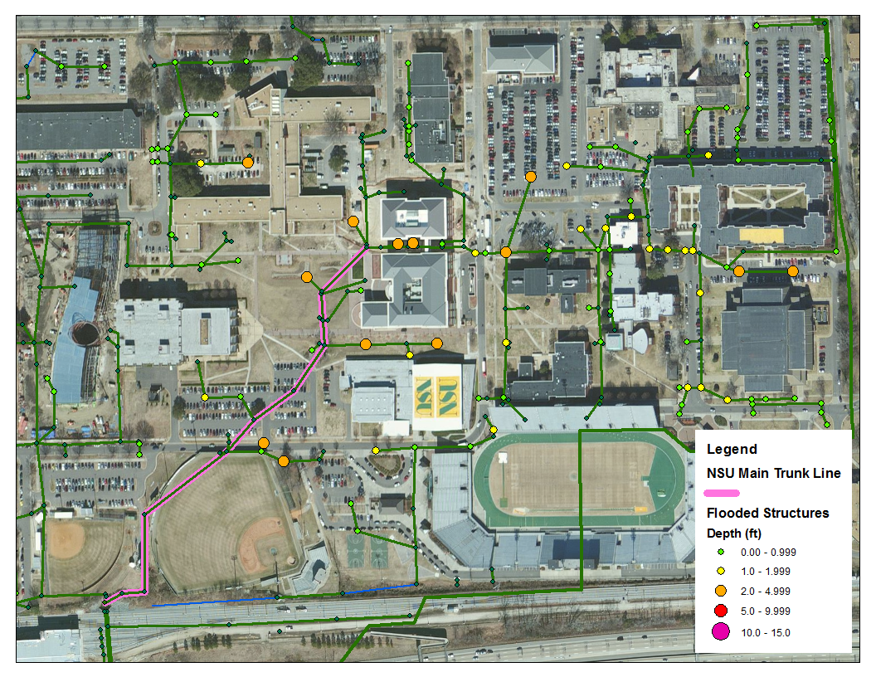
Figure 1. East Norfolk State University Main Trunk Line

Figure 2. Norfolk State University Draft Stormwater Management Master Plan Appendix C: Exceeded Pipe Capacity Exhibit5

North of Park Avenue and Virginia Beach Boulevard
The majority of flooding within the Ohio Creek watershed is concentrated at the intersection of Park Avenue and E. Virginia Beach Boulevard and the corresponding branches north and east of the intersection. A pump station is required to accommodate the additional volume and velocity of flow that will result from these recommended improvements.
Pump Station:
The hydraulic grade downstream and amount of flooding that occurs in Spartan Village during a 10yr MHHW storm event prevent the efficient transport of water from upstream portions of the watershed to the outfall. Timmons Group recommends installing a pump station at the corner of E. Virginia Beach Boulevard and Park Avenue to pump water directly down to the outfall of the Ohio Creek watershed downstream of I-264. A 20-foot by 20-foot wet well is recommended in combination with 3, 90,000gpm pumps to adequately store and transport water downstream during a 10yr storm event. It is recommended to install a dual barrel 72-inch forcemain to travel down Park Avenue and Brambleton Avenue and create a discharge structure next to the existing watershed outfall in the eastern branch of the Elizabeth River. Based on preliminary design conditions, the forcemain discharges 416 cfs of water at peak time. The pump station and forcemain configuration, along with the proposed improvements throughout the watershed, will allow the watershed to discharge 742 cfs of water at peak time which is 420 cfs more water discharged than in existing conditions. A map illustrating the location of the pump station and forcemain can be found in Appendix E.
Park Avenue – Main Trunk Line:
The piped sections along Park Avenue are insufficient to convey stormwater runoff. Timmons Group recommends replacing pipes at a 0.2% slope and increasing the pipe capacity to the equivalent of a 36-inch to a 54-inch pipe downstream through the intersection of Princess Anne Road and Lead Street, increasing in size to the equivalent of a 4-foot by 6-foot box culvert and 6-foot by 8-foot box culvert downstream through the intersection of E. Virginia Beach Boulevard and Park Avenue. To increase the size of the pipes and maintain sufficient ground cover, a total of six curb inlets and seven junction boxes need to be replaced at deeper inverts; one manhole should be removed. A map illustrating the improvements in more detail can be found in Appendix E.
Park Avenue Branch Lines:
Flooding occurs at the curb inlets at the intersection of Park Avenue and E. Virginia Beach Boulevard. Timmons Group recommends replacing the piped sections at a 0.2% slope and increasing the pipe capacity to the equivalent of 36-inch to 48-inch pipes from upstream to downstream through the intersection at E. Virginia Beach Boulevard, respectively. A total of four curb inlets and two junction boxes need to be replaced at deeper inverts in order to correspond to the new pipe slope and maintain sufficient ground cover. A map illustrating the improvements in more detail can be found in Appendix E.
E. Virginia Beach Boulevard:
Insufficiently sized stormwater infrastructure leads to minor flooding along E. Virginia Beach Boulevard and significant flooding along the connecting side streets. Improvements to this collector line are therefore required first in order to accommodate branch improvements. Timmons Group recommends replacing the pipes along E. Virginia Beach Boulevard from the intersection at Merrimac Avenue downstream to the intersection at Park Avenue. Piped sections should be replaced at a 0.2% slope and increased in capacity to the equivalent of a 4-foot by 6-foot box culvert from the intersection at Merrimac Avenue to Majestic Avenue, to a 6-foot by 6-foot box culvert continuing downstream from the intersection of Majestic Avenue to Mapole Avenue, and to a 6-foot by 8-foot box culvert from the intersection at Mapole Avenue to Park Avenue. In addition, a small branch section including two curb inlets between the intersection of Norchester and Merrimac Avenues should be replaced with pipes having the equivalent capacity of 54-inch pipes. In order to replace pipes at a 0.2% slope and maintain sufficient ground cover, a total of nineteen junction boxes and two curb inlets will need to be replaced at deeper inverts. A map illustrating the improvements in more detail can be found in Appendix E.
Marathon Avenue:
The piped sections along Marathon Avenue are insufficient to convey stormwater runoff with some small diameter pipes causing bottlenecks. Timmons Group recommends replacing pipes at a 0.2% slope and increasing the pipe capacity to the equivalent of 48-inch to 60-inch pipes from upstream to downstream respectively. To increase the size of the pipes and maintain sufficient ground cover, a total of eight curb inlets and one grate inlet need to be replaced at deeper inverts. A map illustrating the improvements in more detail can be found in Appendix E.
Merrimac Avenue:
Large drainage areas and insufficiently sized pipes contribute to flooding along Merrimac Avenue. Timmons Group recommends replacing pipes at a 0.2% slope and increasing the pipe capacity to the equivalent of a 60-inch pipe. To increase the size of the pipes and maintain sufficient ground cover, a total of three curb inlets need to be replaced at deeper inverts. A map illustrating the improvements in more detail can be found in Appendix E.
Majestic Avenue:
Major flooding occurs along Majestic Avenue due to insufficiently sized and adversely sloped pipes. Timmons Group recommends replacing pipes at a 0.2% slope and increasing the pipe capacity to the equivalent of a 60-inch pipe. To increase the size of the pipes and maintain sufficient ground cover, a total of thirteen curb inlets and three junction boxes need to be replaced at deeper inverts; one manhole should be removed. A map illustrating the improvements in more detail can be found in Appendix E.
Norchester Avenue:
Major flooding also occurs along Norchester Avenue due to insufficiently sized and adversely sloped pipes. Timmons Group recommends replacing pipes at a 0.2% slope and increasing the pipe capacity to the equivalent of 24-inch to 36-inch pipes from upstream to downstream respectively. To increase the size of the pipes and maintain sufficient ground cover, a total of ten curb inlets and one manhole need to be replaced at deeper inverts. A map illustrating the improvements in more detail can be found in Appendix E.
Kenton Avenue:
The majority of Kenton Avenue located within the Ohio Creek Basin lacks stormwater infrastructure, thus the pipes and structures located north of E. Virginia Beach Boulevard are insufficiently sized to contain the volume of runoff draining to it. Timmons Group recommends replacing pipes at a 0.2% slope and increasing the pipe capacity to the equivalent of a 60-inch pipe. To increase the size of the pipes and maintain sufficient ground cover, a total of three curb inlets need to be replaced at deeper inverts. A map illustrating the improvements in more detail can be found in Appendix E.
Rainey Drive:
During existing conditions there is approximately 2.73 feet of flooding at the curb inlet in the cul-de-sac of Rainey Drive. The existing elevation contours in this area indicate that the flooding is contained within the cul-de-sac as shown in figure 3. The open space next to the structure is a good candidate for the implementation of a best management practice (BMP) such as a bioretention basin or other BMP that has an associated runoff reduction. Due to the low elevation of this area, the cost of increasing pipe capacity along the alignment such that the hydraulic grade remains below the ground is cost prohibitive compared with the cost of implementing a BMP. Timmons Group recommends investigating the possibility of a best management practice to treat the flooding in this area.

Figure 3. Flooding within the Cul-De-Sac of Rainey Drive
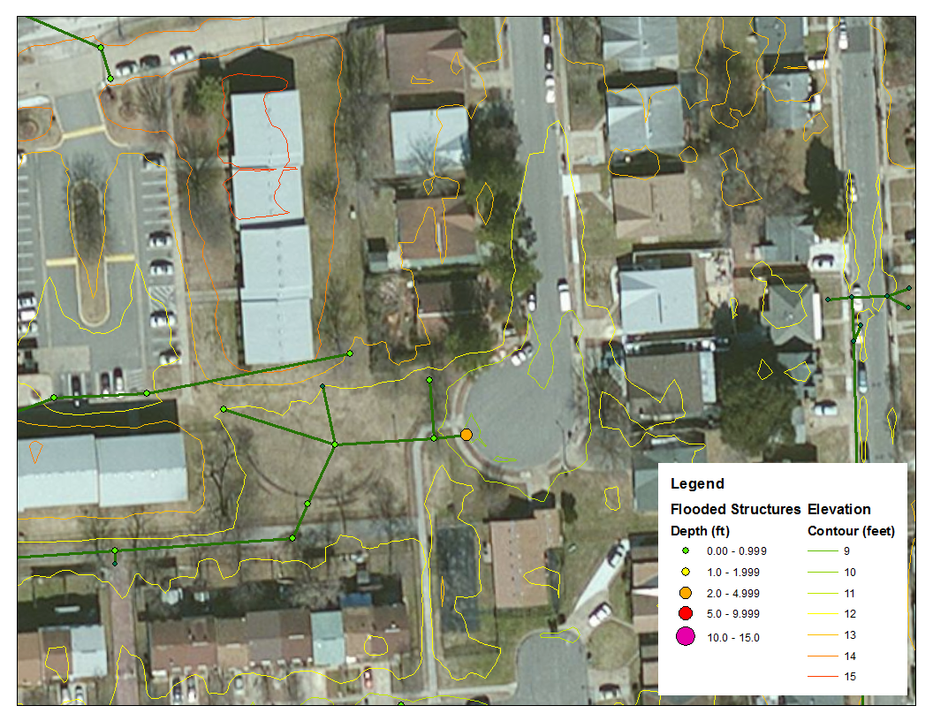
Lead/Link Streets:
To reduce flooding along Lead Street and the end of Link Street, Timmons Group recommends replacing the piped sections at a 0.2% slope and increasing the pipe capacity to the equivalent of a 36-inch pipe. A total of four grate inlets and three curb inlets need to be replaced at deeper inverts in order to correspond to the new pipe slope and maintain sufficient ground cover. A map illustrating the improvements in more detail can be found in Appendix E.

Mapole Avenue:
The piped sections along Mapole Avenue are insufficiently sized and sloped to convey stormwater runoff. Timmons Group recommends replacing pipes at a 0.2% slope and increasing the pipe capacity to the equivalent of 15-inch to 36-inch pipes from upstream to downstream respectively. A total of two curb inlets will need to be replaced at deeper inverts to accommodate the new pipe slope and maintain sufficient ground cover. A map illustrating the improvements in more detail can be found in Appendix E.
E. Princess Anne Road:
Westbound
Due to insufficiently sized pipes, major flooding occurs along the westbound portion of E. Princess Anne Road, to the west of Park Avenue. Timmons Group recommends replacing the piped sections at a 0.2% slope and increasing the pipe capacity to the equivalent of 18-inch to and 36-inch pipes downstream to the intersection of E. Princess Anne Rd and Park Avenue. A total of three curb inlets, one grate inlet, and three manholes need to be replaced at deeper inverts in order to correspond to the new pipe slope and maintain sufficient ground cover.
Eastbound
Minor flooding also occurs on the eastbound portion of E. Princess Anne Road to the west of Park Avenue. Pipes should be replaced at a 0.2% slope and increased in capacity to the equivalent of 24-inch pipes from the intersection at Hanson Avenue to 36-inch pipes downstream to the intersection of E. Princess Anne Rd and Park Avenue. A total of seven curb inlets need to be replaced at deeper inverts to accommodate the new pipe slope and maintain sufficient ground cover.
A map illustrating the improvements for both westbound and eastbound portions of E. Princes Anne Road can be found in Appendix E.

Conclusions
The improvements modeled using Innovyze InfoSWMM version 11.0 indicate that flooding greater than 1’ in depth and most flooding between 0.5’ and 1’ in depth will be eliminated upon implementation of the recommendations described in the preceding section. The general cause of flooding in each critical location is insufficient pipe capacity, downstream head conditions, and in some cases, adversely sloped pipes. In the area north of the intersection of Park Avenue and East Virginia Beach Boulevard, the effect of insufficiently sized stormwater infrastructure is compounded by the backwater effect resulting from the flooding occurring downstream in Spartan Village. To address the flooding in the northern portion of the Ohio Creek watershed, a pump station should be constructed at the intersection of Park Avenue and East Virginia Beach Boulevard to effectively store and transport runoff upstream to the outfall at I-264 during a 10yr MHHW storm event.
To address flooding throughout the watershed, pipes in each improvement area should be replaced at a 0.2% slope and increased in capacity to the equivalent of pipes ranging from 18-inches to 6-foot by 8-foot box culverts. Stormwater structures in these areas should be replaced at deeper inverts to maintain sufficient groundcover and new pipe slopes.
Timmons Group recommends investigating the possibility of implementing a best management practice, such as a bioretention basin or other BMP with runoff reduction qualities, in the open area adjacent to the Rainey Drive cul-de-sac to address flooding in that location.
Timmons Group focused on flooding in roadways and affecting vertical infrastructure and did not therefore address parking areas within the Ohio Creek watershed that were shown to flooding during a 10yr MHHW storm event. Based on the existing elevation contours and grading within the parking lots, it is assumed that flooding is retained within these areas. The improvements necessary to eliminate flooding in these areas would not be cost effective as compared to areas with more significant flooding.
Based on discussions with the City of Norfolk, no recommendations have been made for Spartan Village or the campus of East Norfolk State University.
Table 4 provides the total cost of the proposed improvements for each improvement area and the total for the Ohio Creek watershed. Detailed cost estimates can be found in Appendix D.

Table 4. Total Cost of Proposed Improvements
Ohio Creek Watershed
Corprew St & Joseph St | $1,757,000
Park Av & Olney St | $705,000
Pump Station | $20,396,000
Park Av | $5,367,000
Park Av Branches | $879,000
E. Virginia Beach Blvd | $22,111,000
Marathon Av | $1,200,000
Merrimac Av | $382,000
Majestic Av | $1,437,000
Norchester Av | $1,465,000
Kenton Av | $201,000
Lead St & Link St | $792,000
Mapole Av | $623,000
E. Princess Anne Rd (Westbound) | $1,449,000
E. Princess Anne Rd (Eastbound) | $1,512,000
Total Cost Estimate | $60,276,000

Additional Recommendations
While conducting the field inventory portion of this project, Timmons Group field personnel inventoried many structures, pipes, and ditches which were partially to fully blocked (trash, sediment, buried, etc.). It is also our recommendation that these structures be unblocked or located (if buried) to increase the efficiency of the existing stormwater infrastructure which should alleviate some existing flooding issues faced by the City of Norfolk.

Appendix A
Graphical Depictions of Structure Flooding Depths

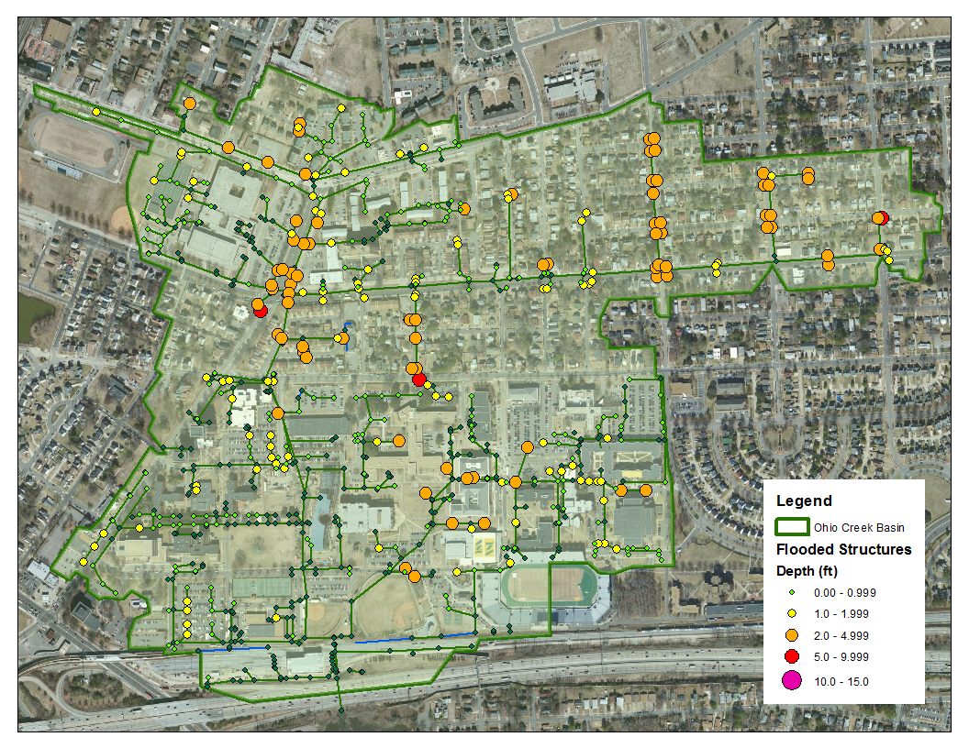
A.1 Existing Conditions - Water Depths at Time of Peak Watershed Flooding for 10yr MHHW Storm Event

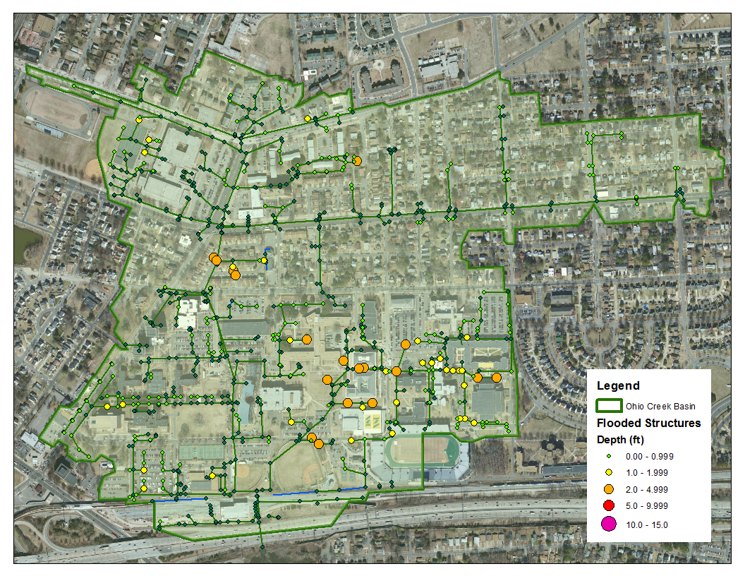
A.2 Proposed Improvements - Water Depths at Time of Peak Watershed Flooding for 10yr MHHW Storm Event

Appendix B
Existing Conditions HGL Profile Plots

B.1 South of Intersection of Park Avenue and E. Virginia Beach Boulevard

B.1.a Corprew Avenue and Joseph Street to Main Trunk Line
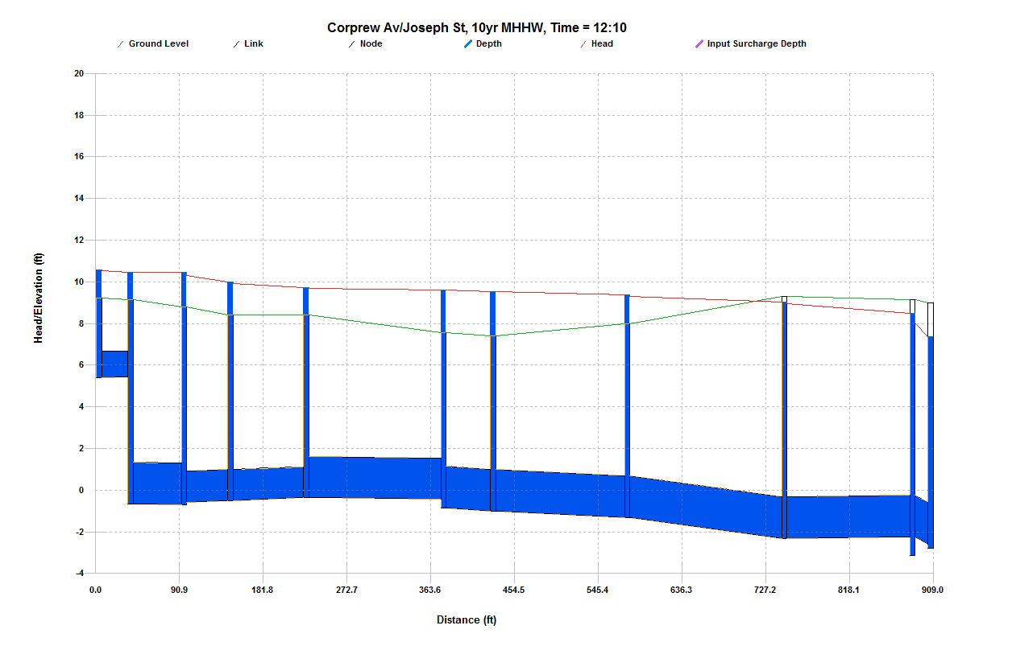

G152342

G1522891A
Refer to Main Trunk Line HGL for continuation to the Outfall.

B.1 South of Intersection of Park Avenue and E. Virginia Beach Boulevard (cont’d)

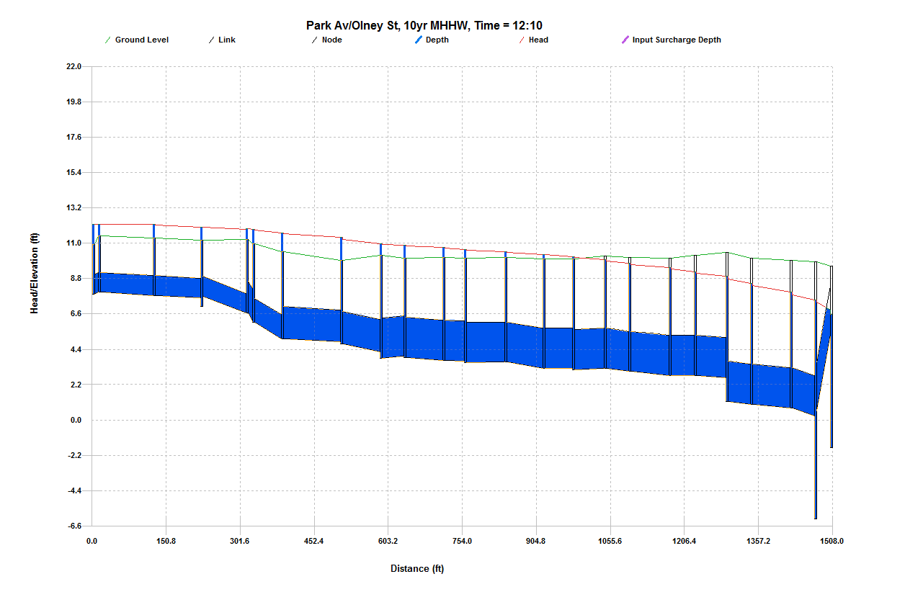
B.1.b Park Avenue and Olney Street to Main Trunk Line
G152245
Begin Improvement Section
G1573183
End Improvement Section
G1573146
Refer to Main Trunk Line HGL for continuation to the Outfall.

B.1 South of Intersection of Park Avenue and E. Virginia Beach Boulevard (cont’d)

B.1.c Spartan Village
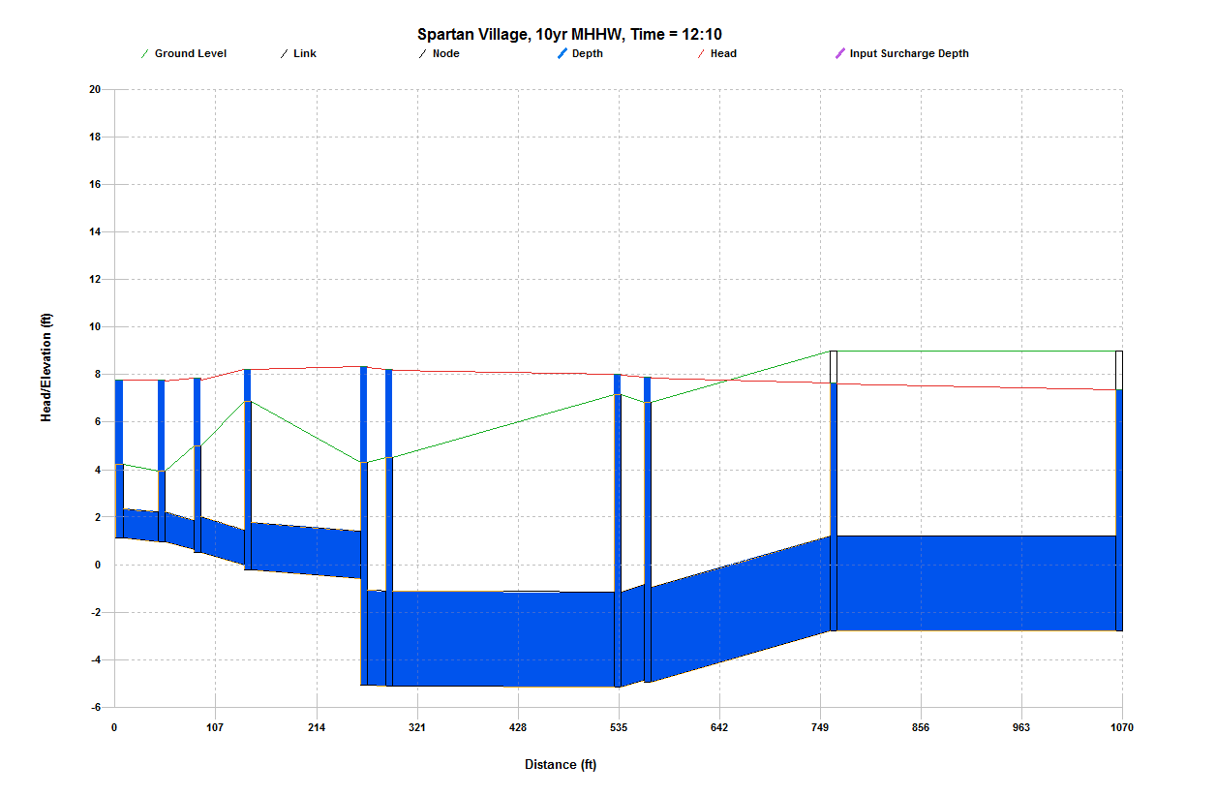

G1522891A
Refer to Main Trunk Line HGL for continuation to the Outfall.

G157308

B.1 South of Intersection of Park Avenue and E. Virginia Beach Boulevard (cont’d)

B.1.d East Norfolk State University

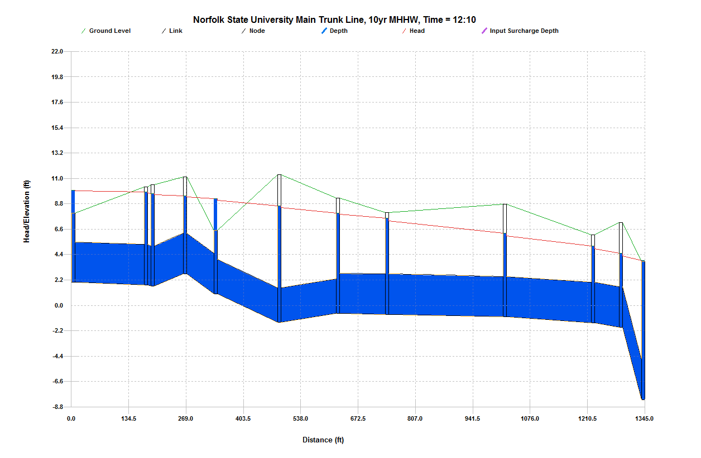
CH1
Refer to Main Line HGL for continuation to the Outfall.

H153549

B.2 North of Intersection of Park Avenue and E. Virginia Beach Boulevard

B.2.a Park Avenue Branches
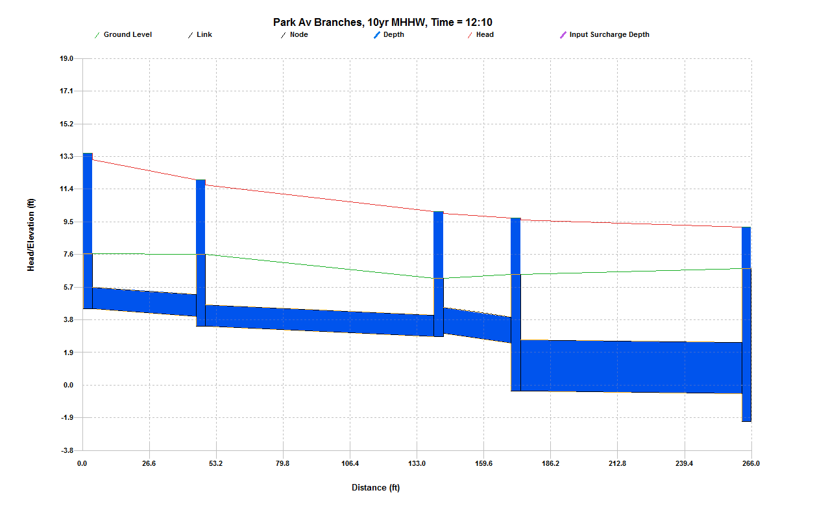
G152482
Refer to Park Avenue Main Trunk Line HGL for continuation to the Outfall.

G152503

B.2 North of Intersection of Park Avenue and E. Virginia Beach Boulevard (cont’d)

B.2.b Park Avenue Main Trunk Line
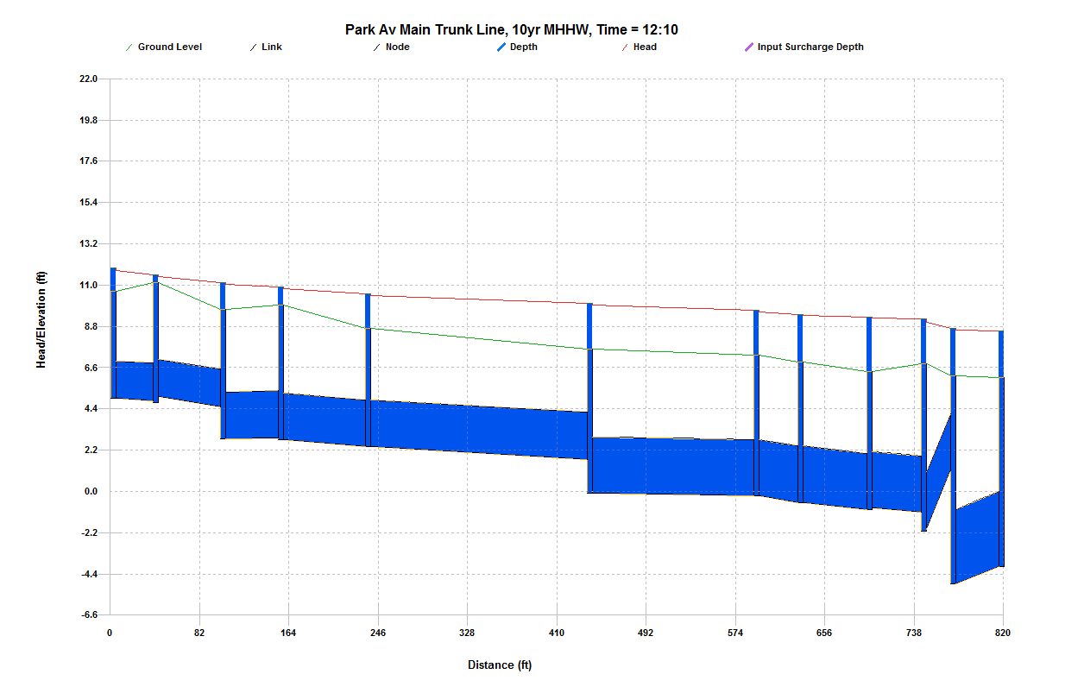

G142610

G152361
Refer to Main Trunk Line HGL for continuation to the Outfall.

B.2 North of Intersection of Park Avenue and E. Virginia Beach Boulevard (cont’d)

B.2.c E. Virginia Beach Boulevard
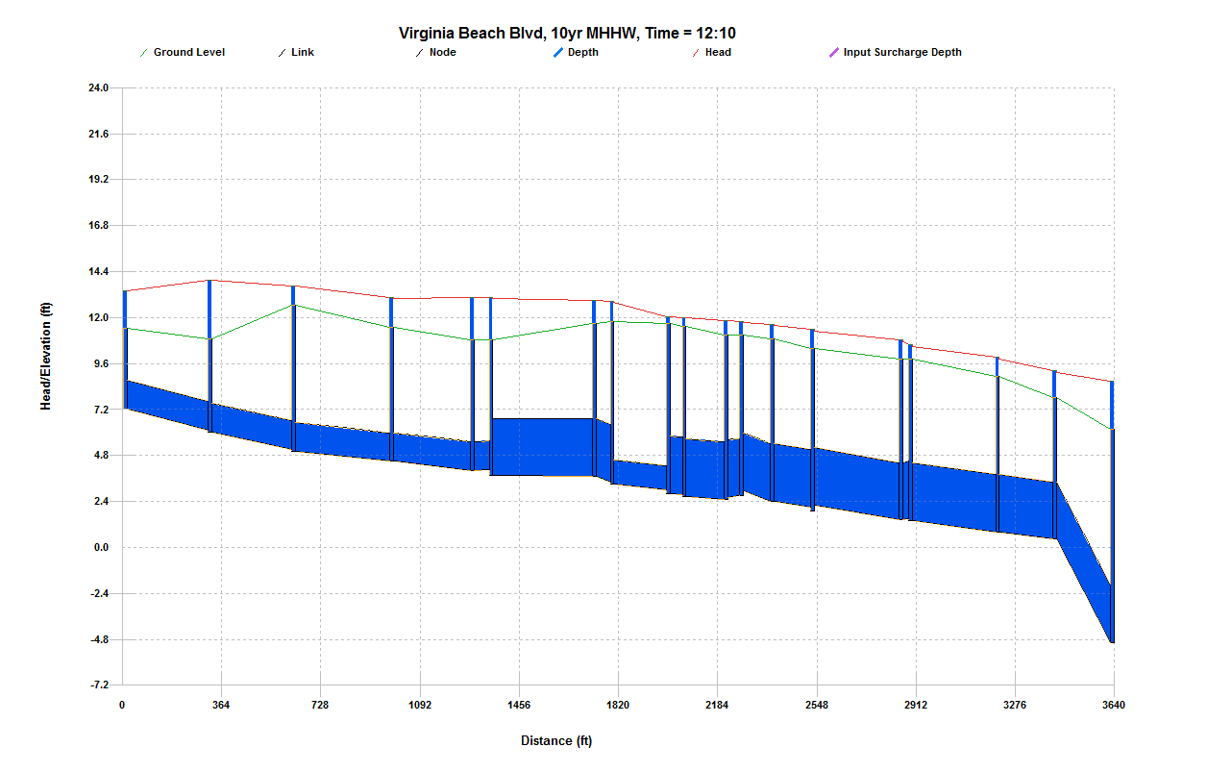
G152363
Refer to Main Trunk Line HGL for continuation to the Outfall.

I152473

B.2 North of Intersection of Park Avenue and E. Virginia Beach Boulevard (cont’d)

B.2.d Marathon Avenue to E. Virginia Beach Boulevard
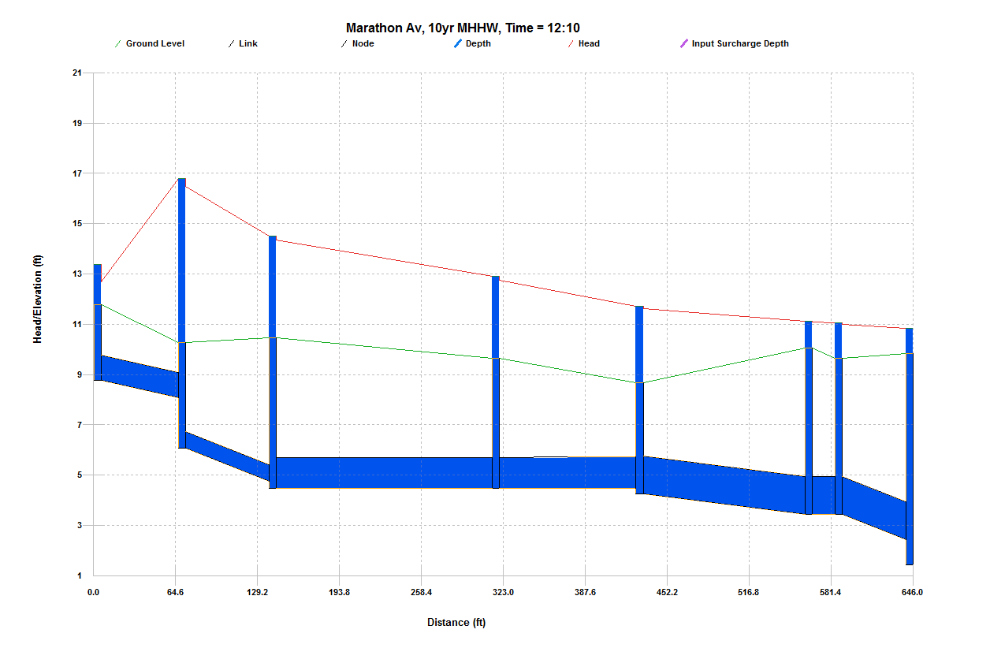
H152380
Refer to Virginia Beach Boulevard HGL for continuation to the Main Trunk Line.

H153464

B.2 North of Intersection of Park Avenue and E. Virginia Beach Boulevard (cont’d)

B.2.e Merrimac Avenue to E. Virginia Beach Boulevard
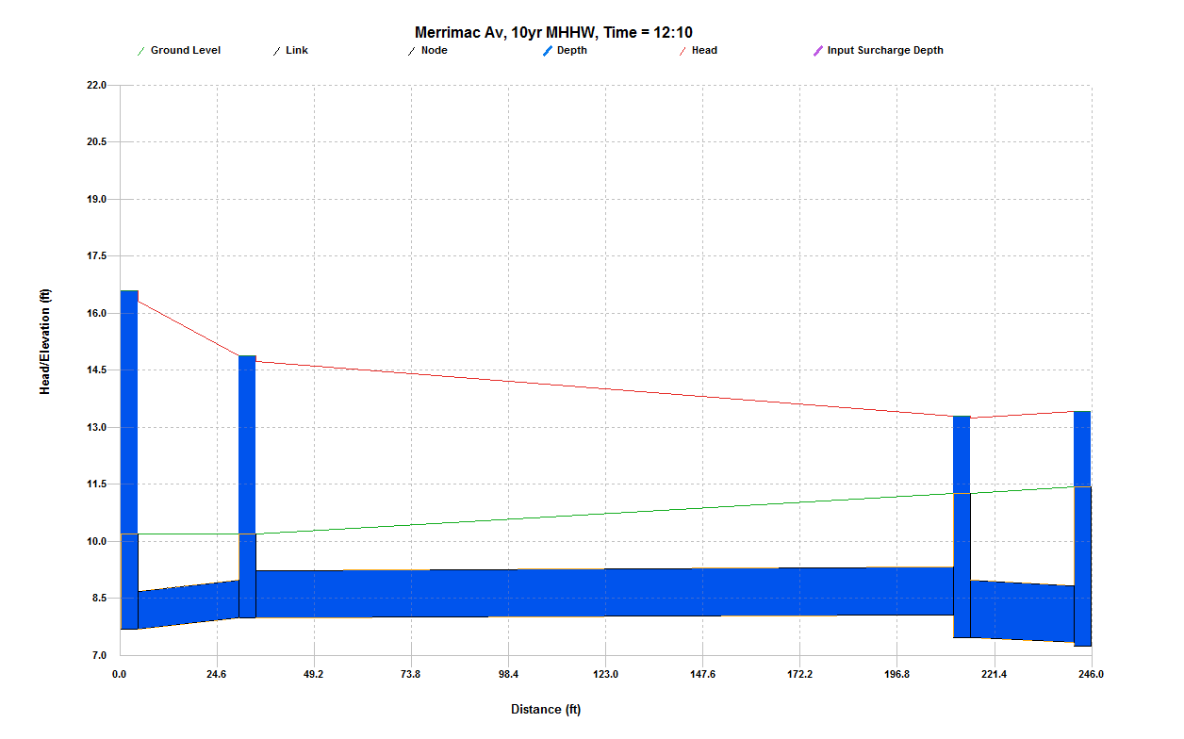
I152473
Refer to Virginia Beach Boulevard HGL for continuation to the Main Trunk Line.

I152480

B.2 North of Intersection of Park Avenue and E. Virginia Beach Boulevard (cont’d)

B.2.f Majestic Avenue to E. Virginia Beach Boulevard
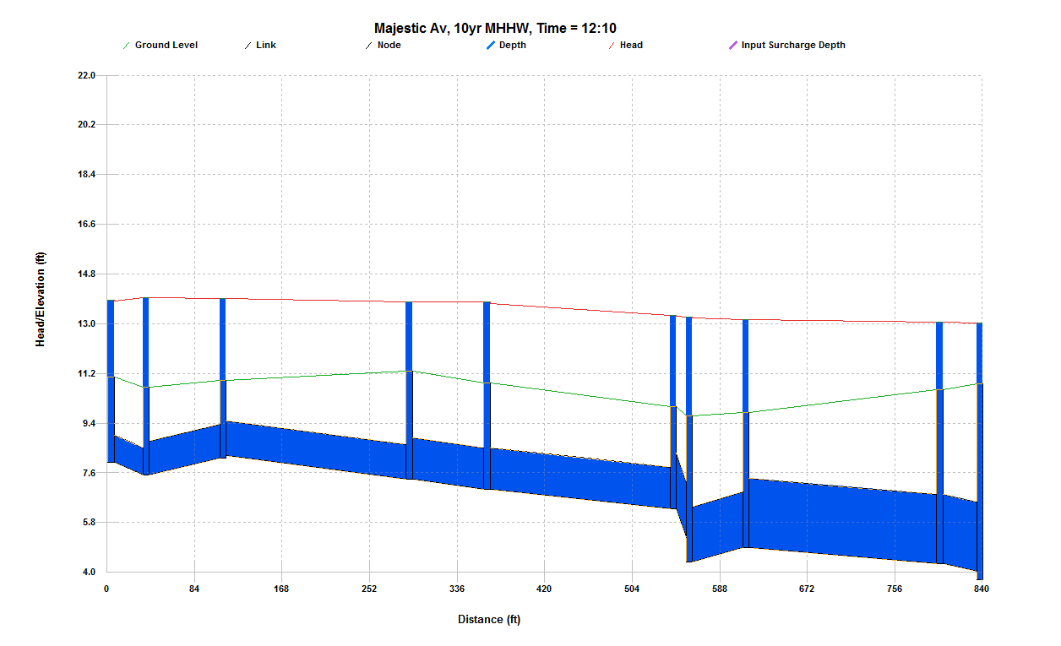
H142451

H152435
Refer to Virginia Beach Boulevard HGL for continuation to the Main Trunk Line.

B.2 North of Intersection of Park Avenue and E. Virginia Beach Boulevard (cont’d)

B.2.g Norchester Avenue to E. Virginia Beach Boulevard
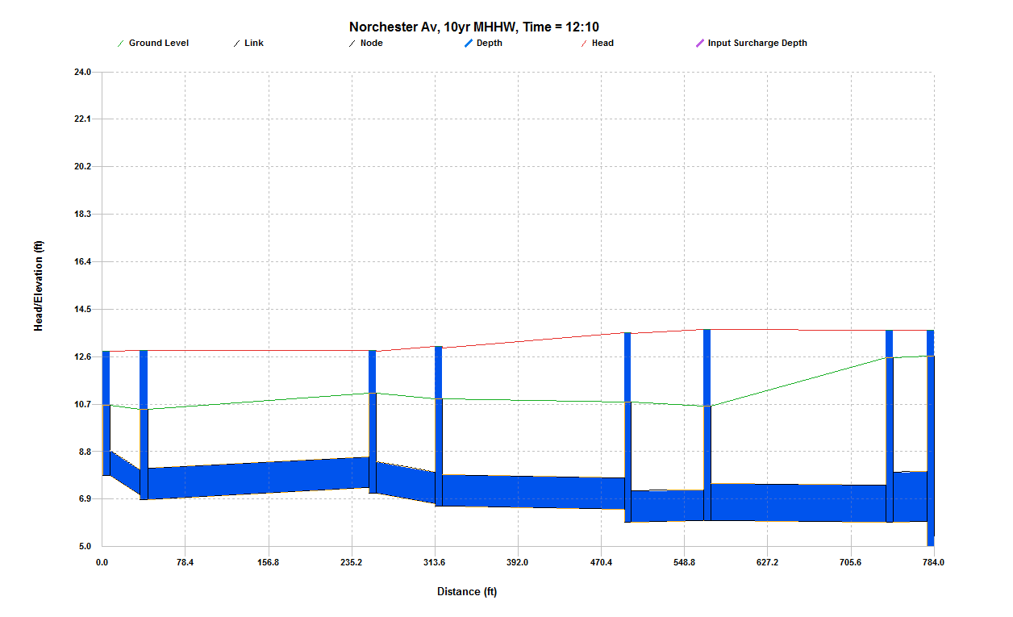
H152458
Refer to Virginia Beach Boulevard HGL for continuation to the Main Trunk Line.

H142469

B.2 North of Intersection of Park Avenue and E. Virginia Beach Boulevard (cont’d)

B.2.h Kenton Avenue to E. Virginia Beach Boulevard
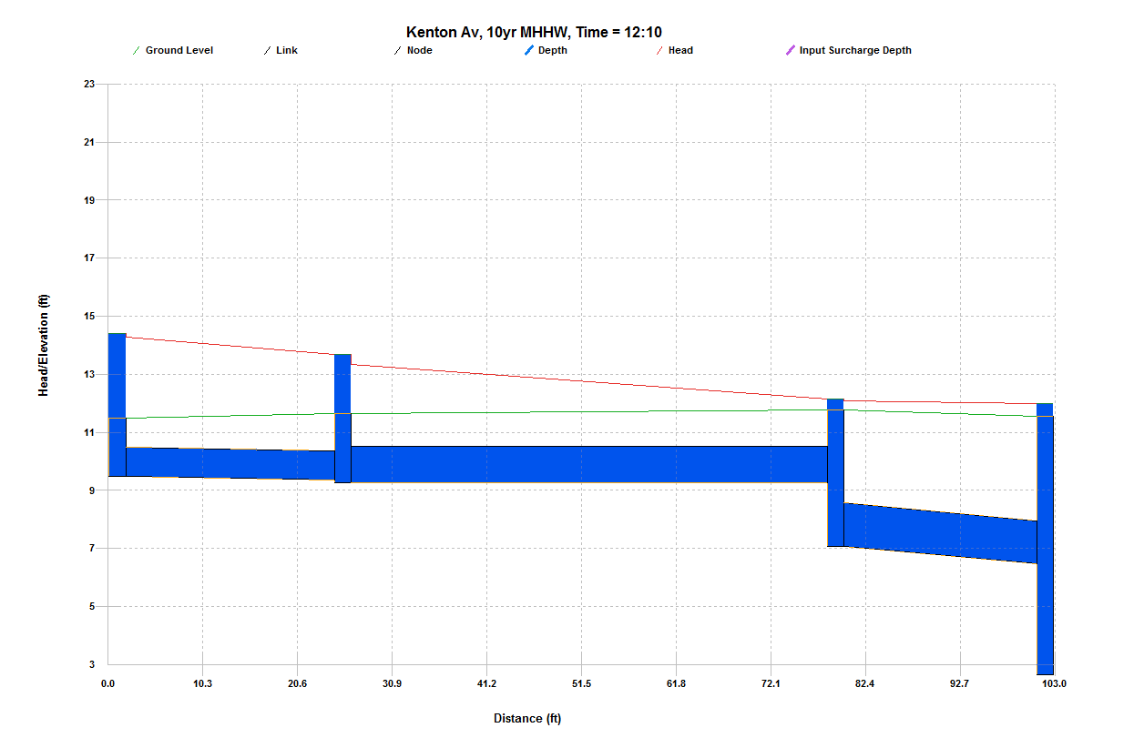
H152416
Refer to Virginia Beach Boulevard HGL for continuation to the Main Trunk Line.

H152420

B.2 North of Intersection of Park Avenue and E. Virginia Beach Boulevard (cont’d)

B.2.i Lead Street & Link Street to Park Avenue
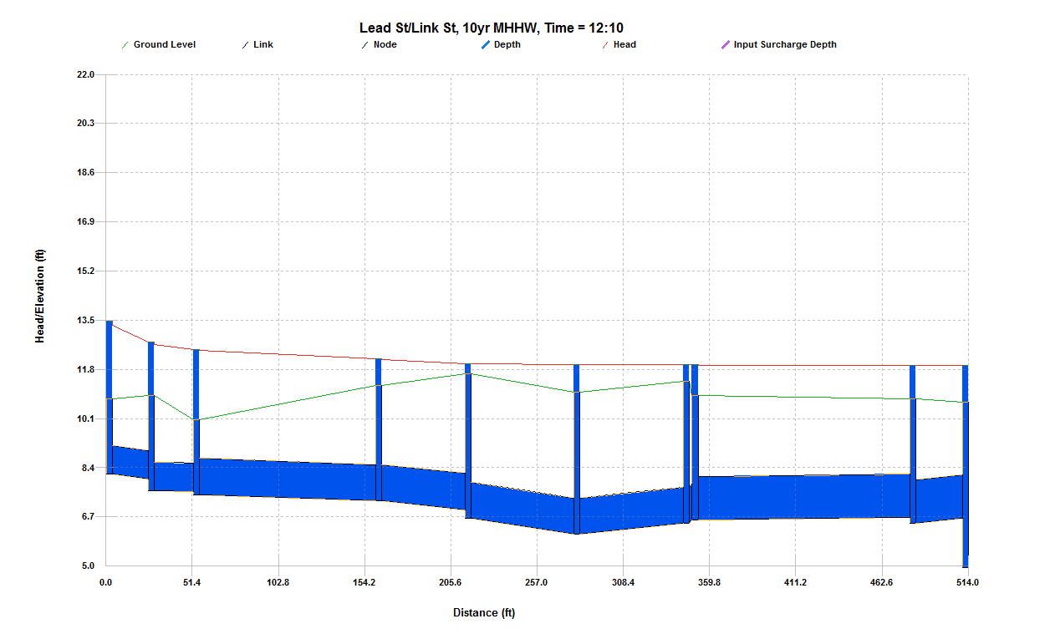
G142610
Refer to Park Avenue Main Trunk Line HGL for continuation to the Main Trunk Line.

G142626

B.2 North of Intersection of Park Avenue and E. Virginia Beach Boulevard (cont’d)

B.2.j Mapole Avenue to E. Virginia Beach Boulevard
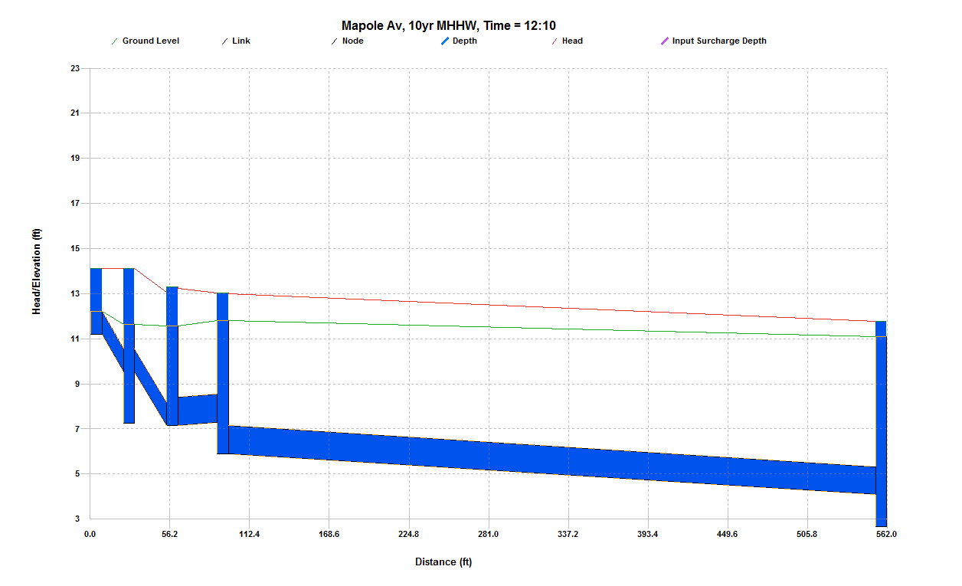
H152406
Refer to Virginia Beach Boulevard HGL for continuation to the Main Trunk Line.

H142412

B.2 North of Intersection of Park Avenue and E. Virginia Beach Boulevard (cont’d)

B.2.k E. Princess Anne Road (Westbound) from Park Avenue
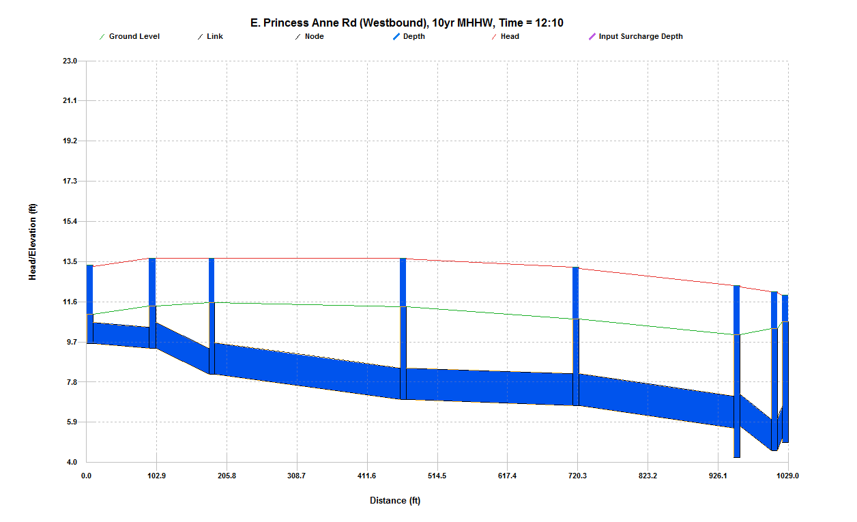
G142610
Refer to Park Avenue HGL for continuation to the Main Trunk Line.

G142620

B.2 North of Intersection of Park Avenue and E. Virginia Beach Boulevard (cont’d)

B.2.l E. Princess Anne Road (Eastbound) to Park Avenue
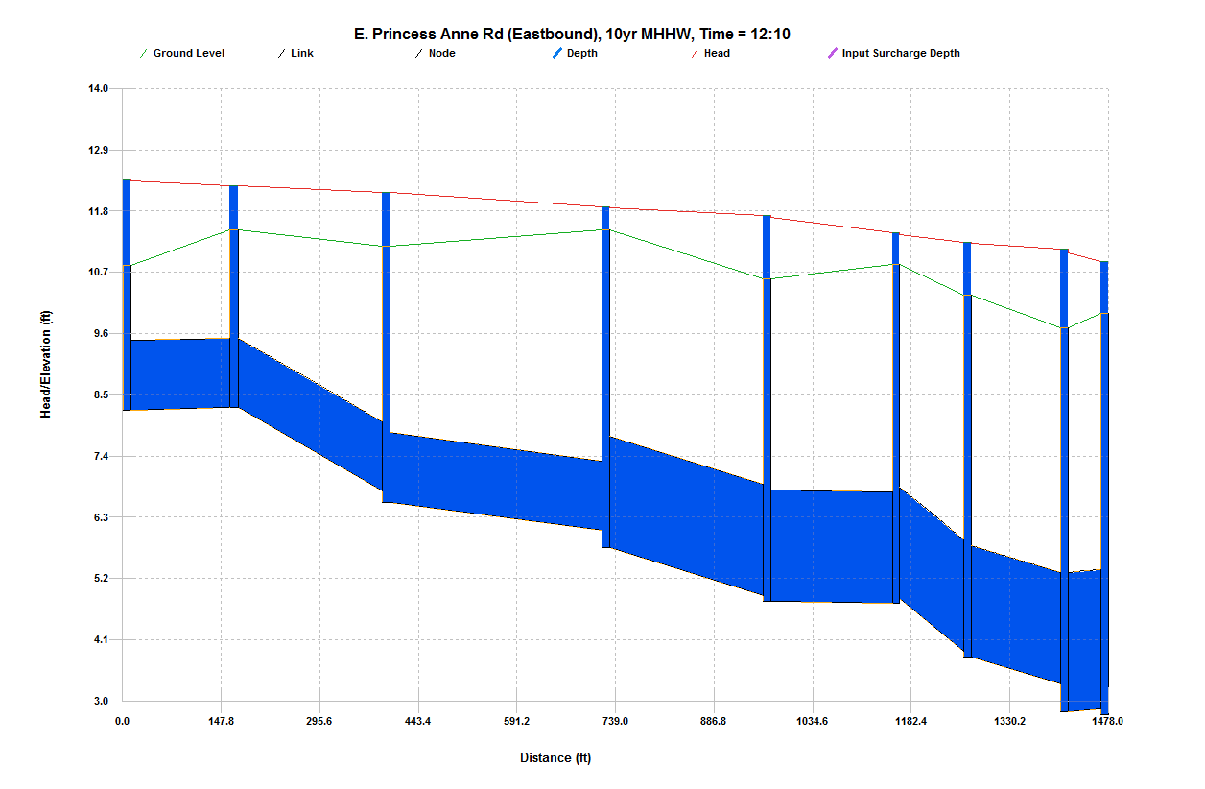
G142585
Refer to Park Avenue HGL for continuation to the Main Trunk Line.

G142593

B.3 Ohio Creek Main Trunk Line
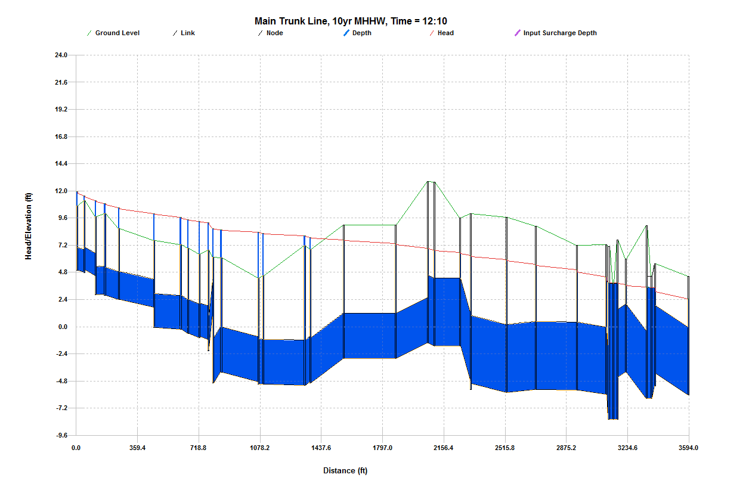
Spartan
Village
G152363
Virginia Beach Boulevard
CH1
G142610
Park Avenue
G1522891A
G1573146
Outfall

Appendix C
Improvement Scenario HGL Profile Plots

C.1 South of Intersection of Park Avenue and E. Virginia Beach Boulevard

C.1.a Corprew Avenue and Joseph Street to Main Trunk Line
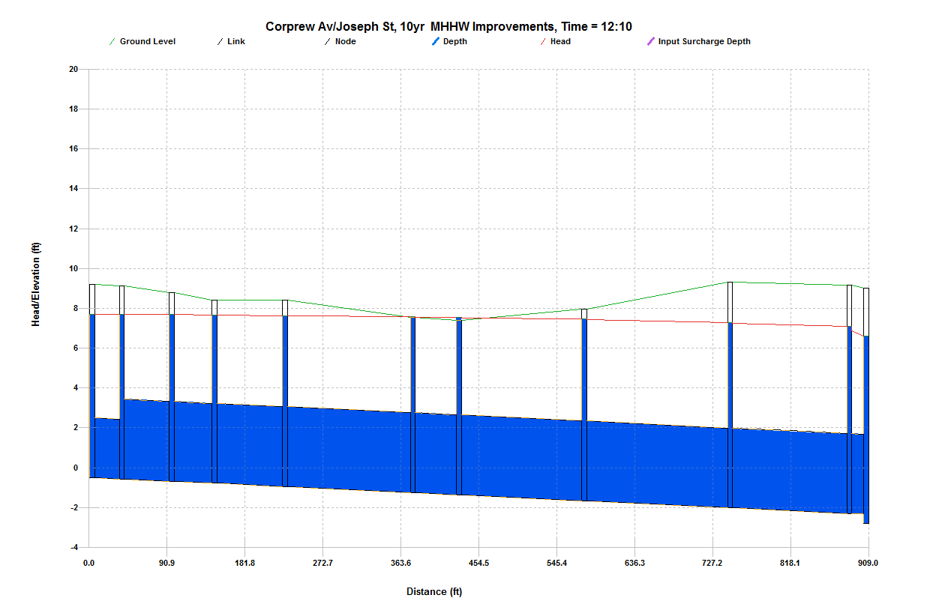

G1522891A
Refer to Main Trunk Line HGL for continuation to the Outfall.

G152342

C.1 South of Intersection of Park Avenue and E. Virginia Beach Boulevard (cont’d)

C.1.b Park Avenue and Olney Street to Main Trunk Line
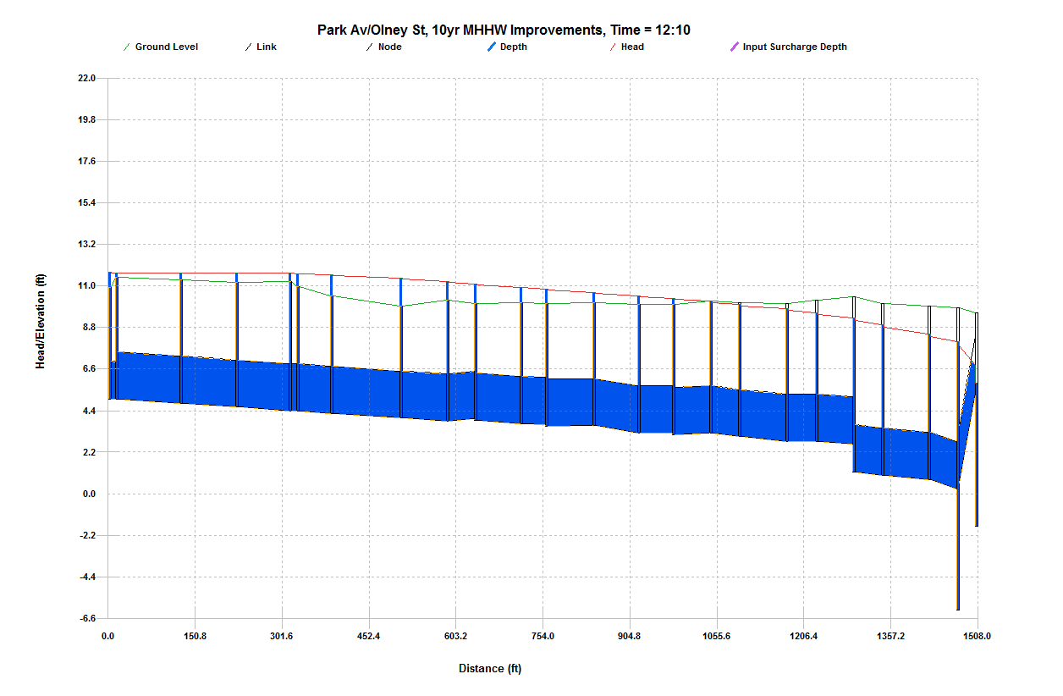
G1573183
End Improvement Section
G152245
Begin Improvement Section
G1573146
Refer to Main Trunk Line HGL for continuation to the Outfall.

C.2 North of Intersection of Park Avenue and E. Virginia Beach Boulevard (cont’d)

C.2.a Park Avenue Branches
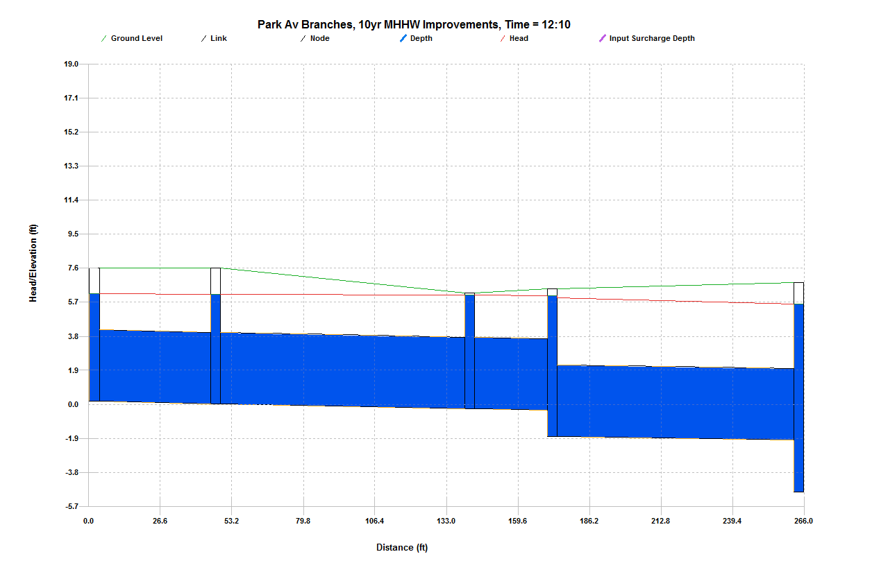
G152482
Refer to Park Avenue Main Trunk Line HGL for continuation to the Outfall.

G152503

C.2 North of Intersection of Park Avenue and E. Virginia Beach Boulevard (cont’d)

C.2.b Park Avenue Main Trunk Line
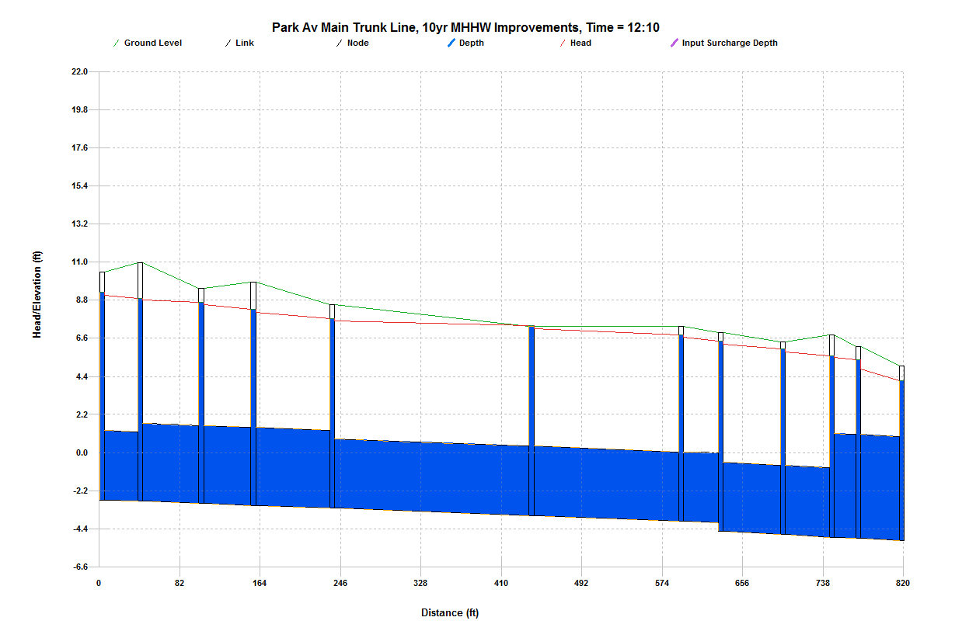

G152361
Refer to Main Trunk Line HGL for continuation to the Outfall.

G142610

C.2 North of Intersection of Park Avenue and E. Virginia Beach Boulevard (cont’d)

C.2.c E. Virginia Beach Boulevard
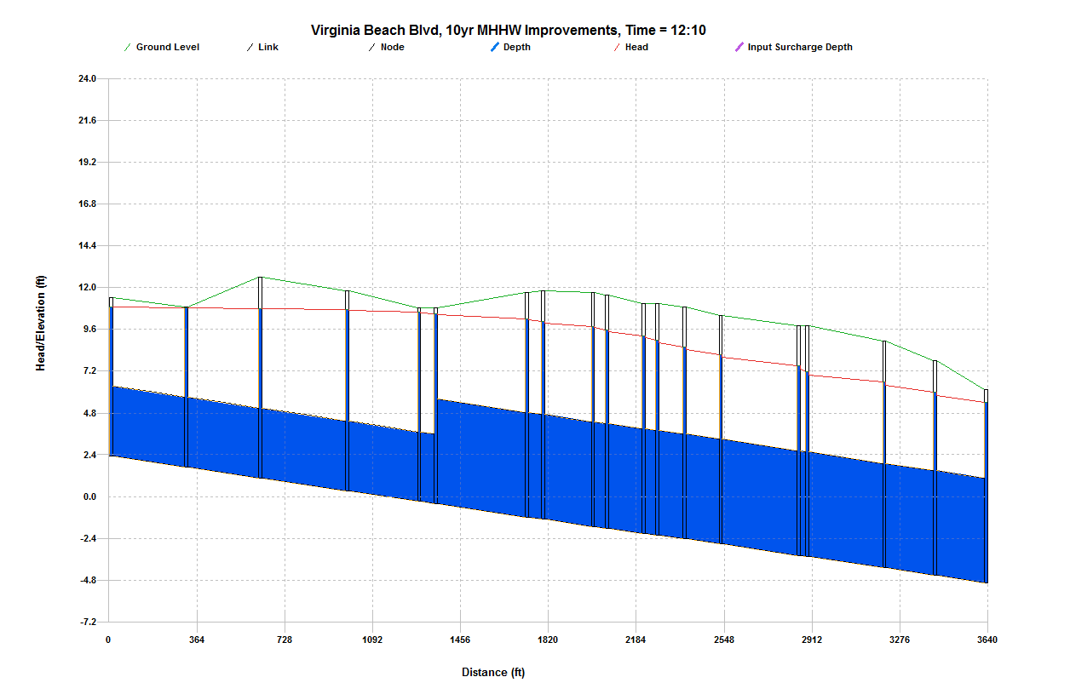

G152363
Refer to Main Trunk Line HGL for continuation to the Outfall.

I152473

C.2 North of Intersection of Park Avenue and E. Virginia Beach Boulevard (cont’d)

C.2.d Marathon Avenue to E. Virginia Beach Boulevard
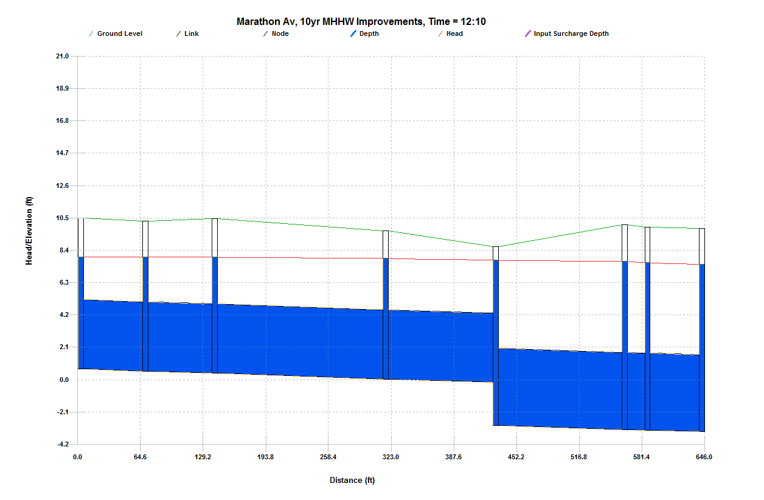
H152380
Refer to Virginia Beach Boulevard HGL for continuation to the Main Trunk Line.

H152394

C.2 North of Intersection of Park Avenue and E. Virginia Beach Boulevard (cont’d)

C.2.e Merrimac Avenue to E. Virginia Beach Boulevard
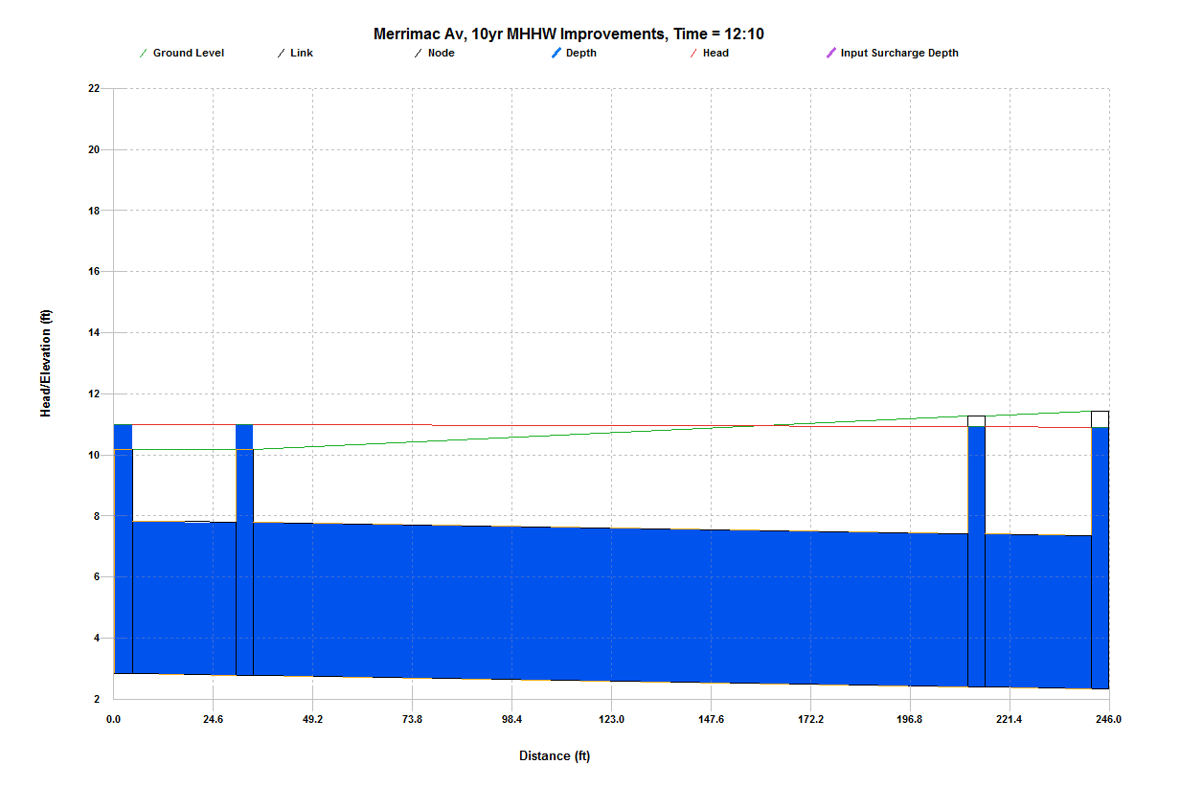
I152473
Refer to Virginia Beach Boulevard HGL for continuation to the Main Trunk Line.

I152480

C.2 North of Intersection of Park Avenue and E. Virginia Beach Boulevard (cont’d)

C.2.f Majestic Avenue to E. Virginia Beach Boulevard
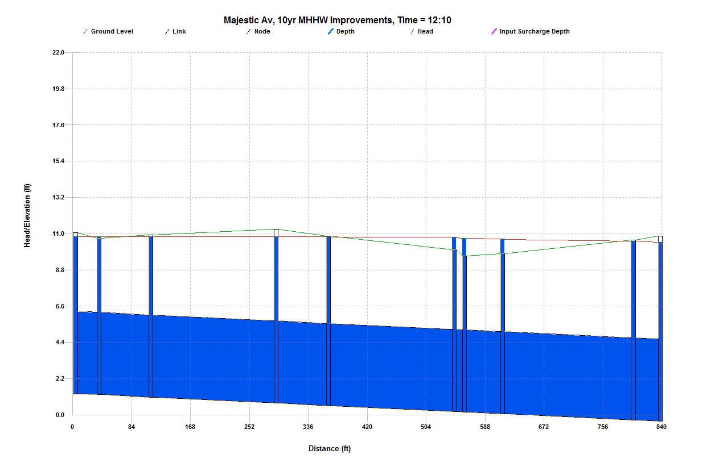
H142451

H152435
Refer to Virginia Beach Boulevard HGL for continuation to the Main Trunk Line.

C.2 North of Intersection of Park Avenue and E. Virginia Beach Boulevard (cont’d)

C.2.g Norchester Avenue to E. Virginia Beach Boulevard
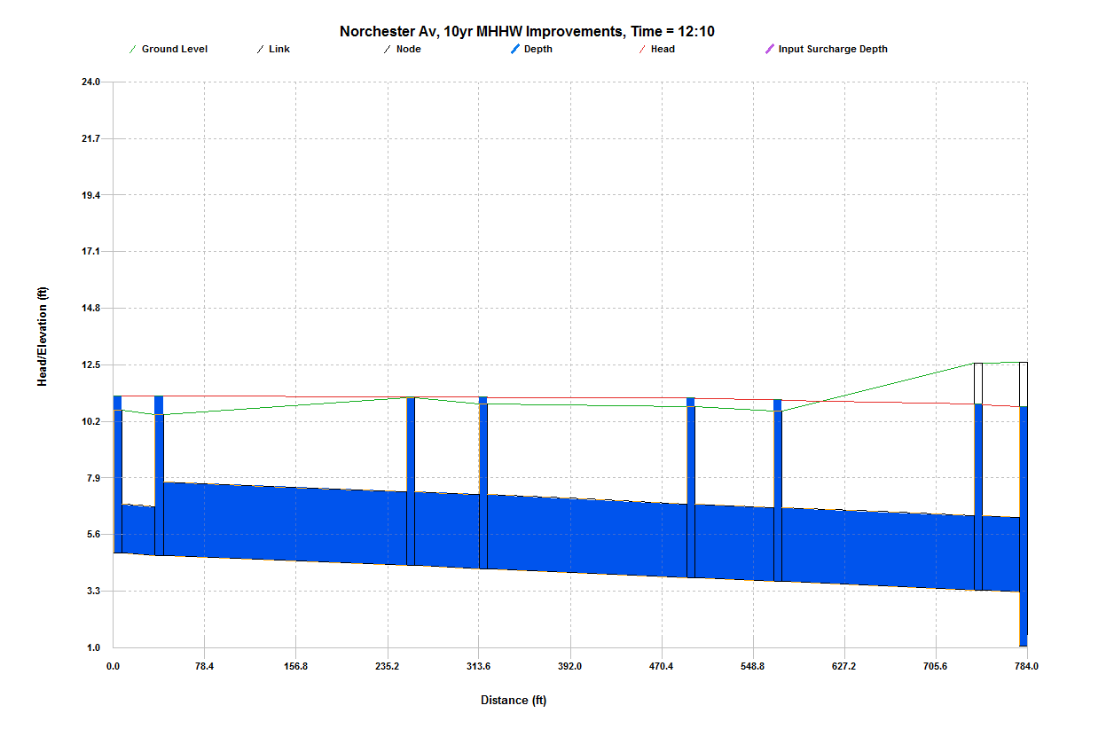

H152458
Refer to Virginia Beach Boulevard HGL for continuation to the Main Trunk Line.

H142469

C.2 North of Intersection of Park Avenue and E. Virginia Beach Boulevard (cont’d)

C.2.h Kenton Avenue to E. Virginia Beach Boulevard
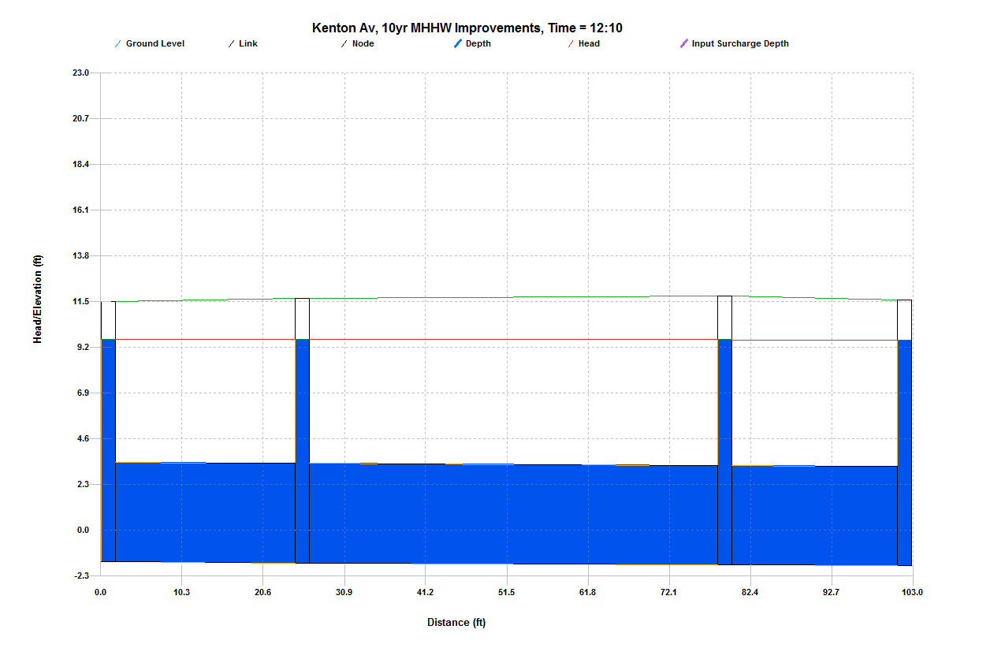
H152420

H152416
Refer to Virginia Beach Boulevard HGL for continuation to the Main Trunk Line.

C.2 North of Intersection of Park Avenue and E. Virginia Beach Boulevard (cont’d)

C.2.i Lead Street & Link Street to Park Avenue
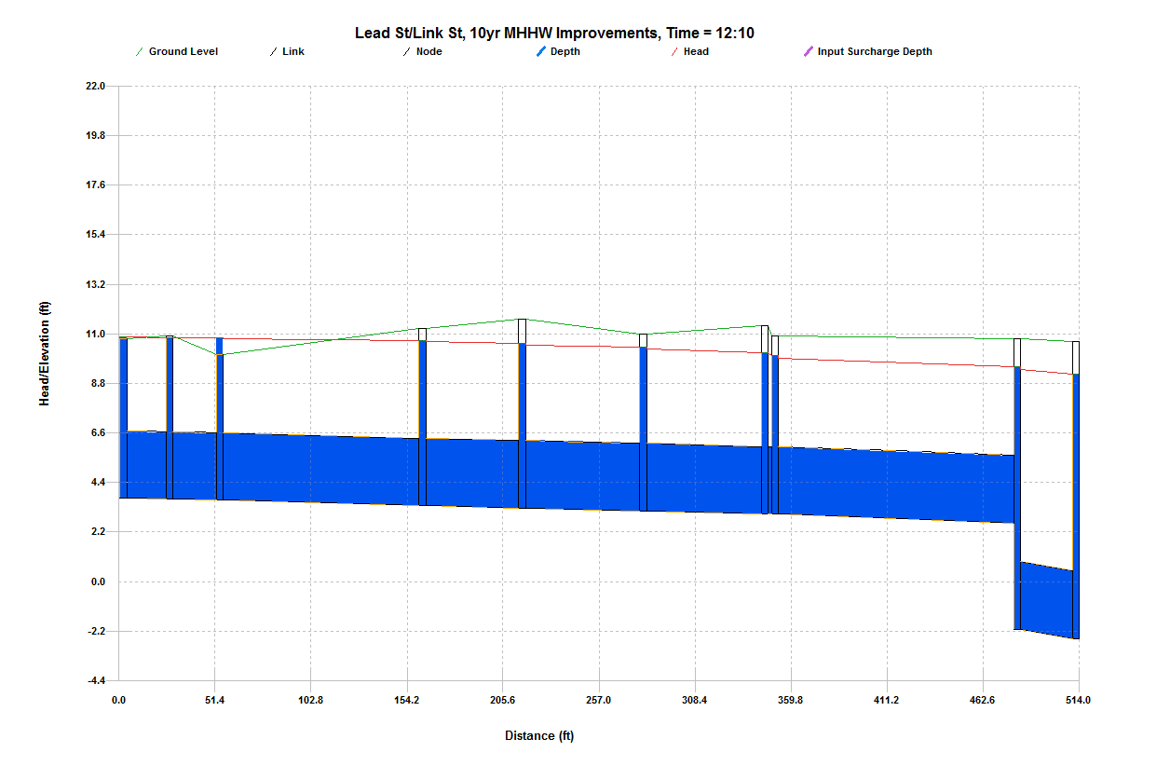
G142610
Refer to Park Avenue Main Trunk Line HGL for continuation to the Main Trunk Line.

G142626

C.2 North of Intersection of Park Avenue and E. Virginia Beach Boulevard (cont’d)

C.2.j Mapole Avenue to E. Virginia Beach Boulevard
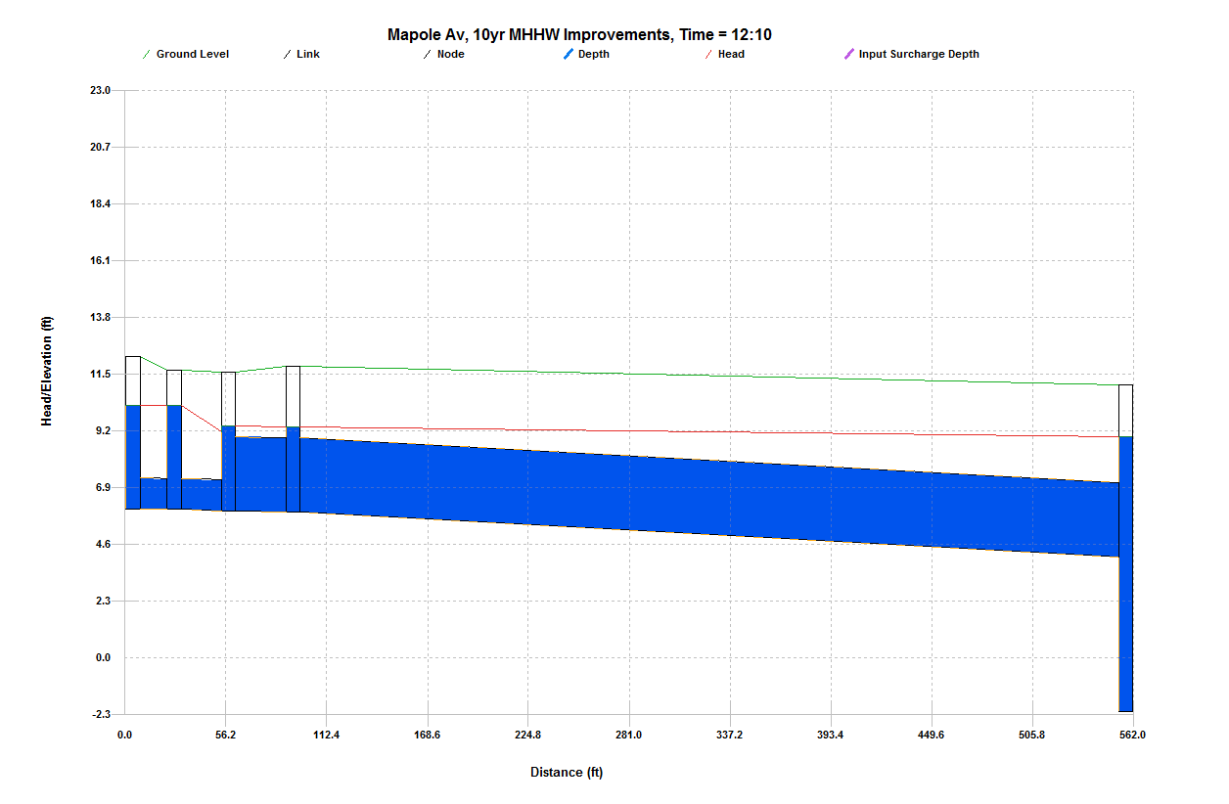

H152406
Refer to Virginia Beach Boulevard HGL for continuation to the Main Trunk Line.

H142412

C.2 North of Intersection of Park Avenue and E. Virginia Beach Boulevard (cont’d)

C.2.k E. Princess Anne Road (Westbound) to Park Avenue
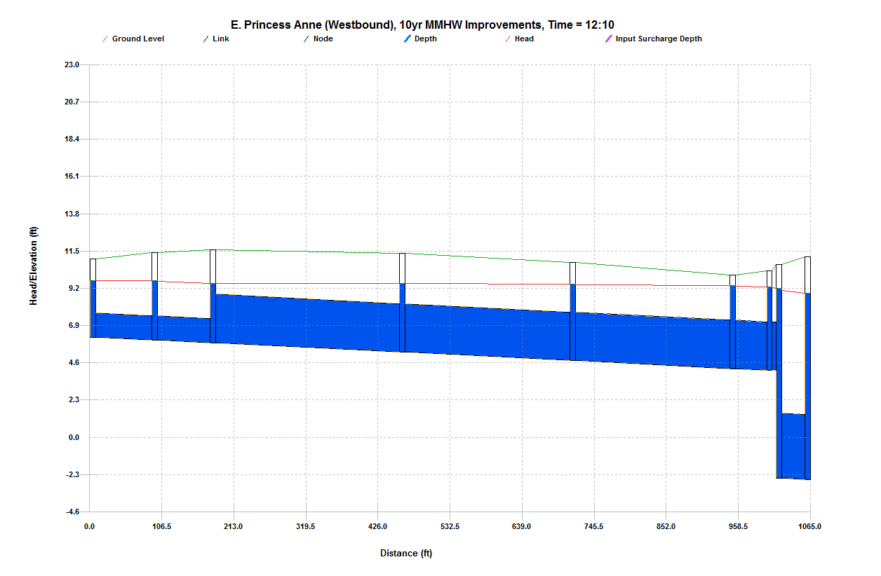
G142610
Refer to Park Avenue HGL for continuation to the Main Trunk Line.

G142620

C.2 North of Intersection of Park Avenue and E. Virginia Beach Boulevard (cont’d)

C.2.l E. Princess Anne Road (Eastbound) to Park Avenue
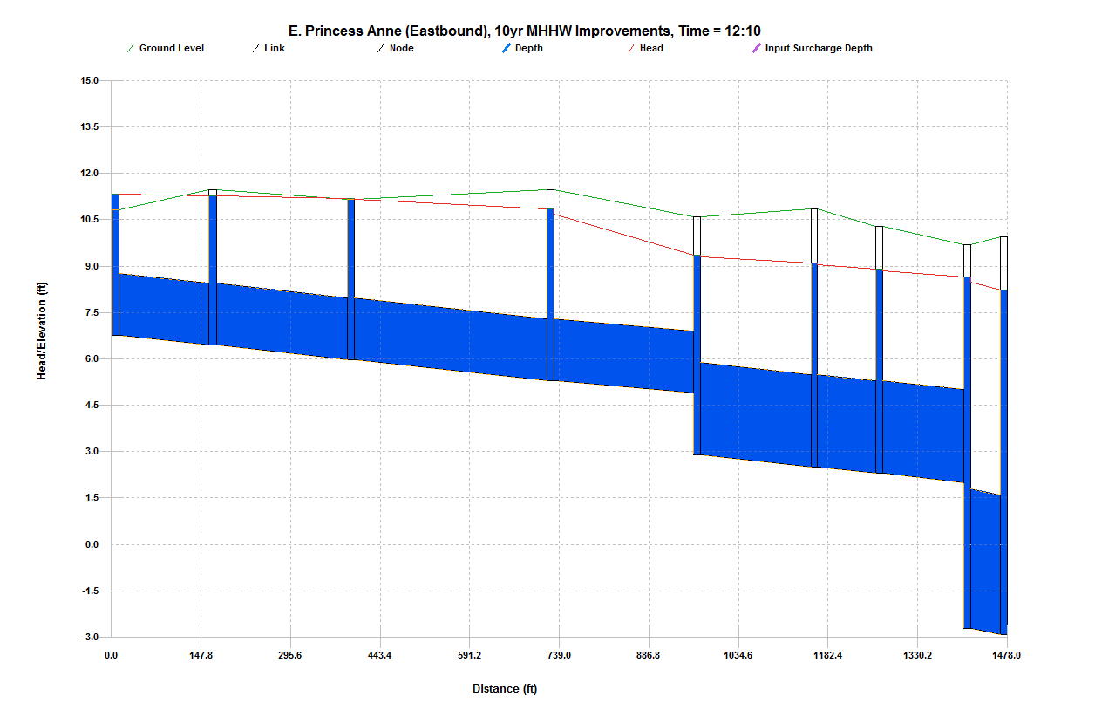
G142585
Refer to Park Avenue HGL for continuation to the Main Trunk Line.

G142593

C.3 Ohio Creek Main Trunk Line
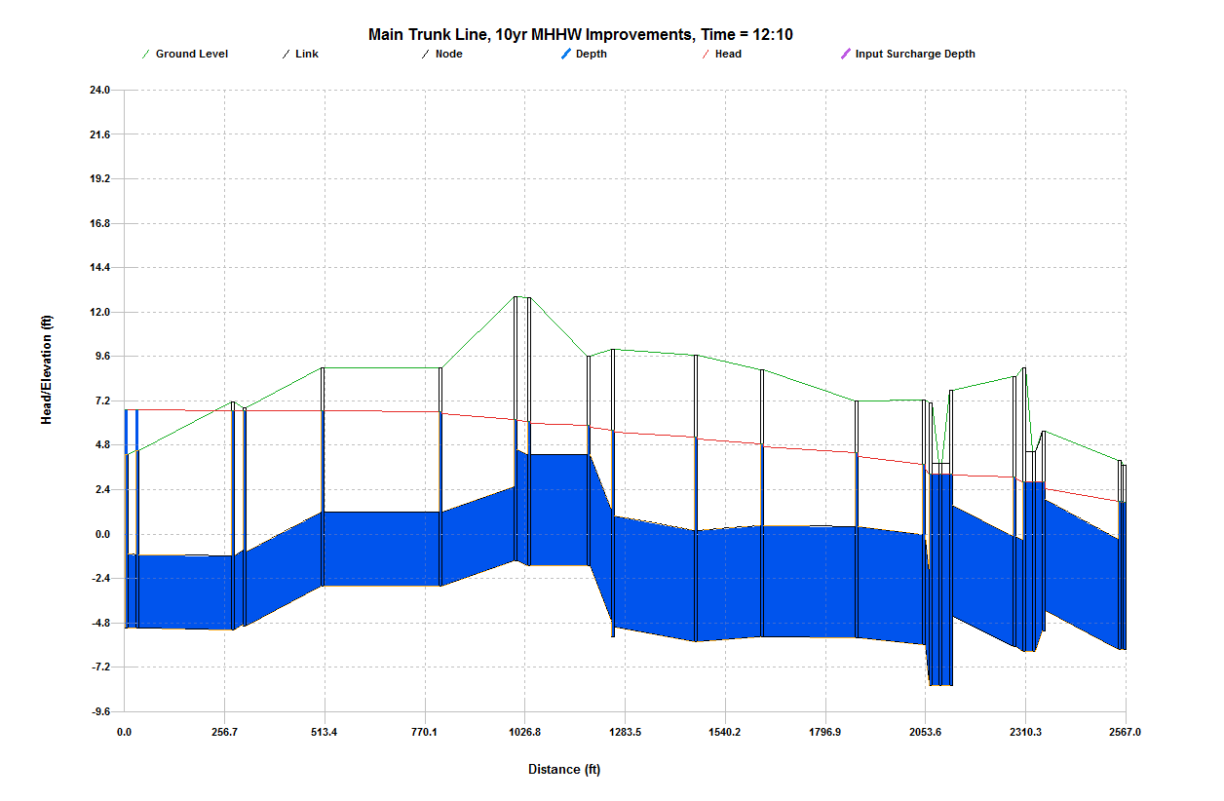

Outfall

CH1
G1573146
G1522891A
Spartan
Village

Appendix D
Improvement Scenario Cost Estimates

D.1.a Corprew Avenue & Joseph Street Cost Estimate
I. Paving and Earthwork
 | Total | Unit |  | Unit Cost |  | Total
Road Patch, Mill, & Overlay | 10275 | SY | @ | $ 45.00 | = | $ 462,375.00
Curb & Gutter | 540 | LF | @ | $ 30.00 | = | $ 16,200.00
Subtotal Paving and Earthwork |  |  |  |  |  | $ 478,575.00
II. Storm Drainage
36" RCP (Class III)* | 131 | LF | @ | $ 140.00 | = | $ 18,340.00
48" RCP (Class III)* | 1182 | LF | @ | $ 205.00 | = | $ 242,310.00
Stone Backfill | 683 | CY | @ | $ 27.00 | = | $ 18,441.00
Curb Inlet | 11 | EA | @ | $ 3,000.00 | = | $ 33,000.00
Junction Box | 9 | EA | @ | $ 5,000.00 | = | $ 45,000.00
Subtotal Storm Drainage Excavation |  |  |  |  |  | $ 357,091.00
*includes bedding, excavation, and earthen backfill. Does not include stone backfill.
III. Streetscape
Street Trees | 540 | LF | @ | $ 15.00 | = | $ 8,100.00
Yard Grading | 775 | LF | @ | $ 20.00 | = | $ 15,500.00
Sidewalk | 3083 | SY | @ | $ 35.00 | = | $ 107,905.00
Topsoil and Seed | 775 | LF | @ | $ 35.00 | = | $ 27,125.00
Subtotal Streetscape |  |  |  |  |  | $ 158,630.00
IV. Mark-Ups
Design Contingencies (12%) |  |  | @ |  | = | $ 119,316.00
Mobilization & Demolition (8%) |  |  | @ |  | = | $ 79,544.00
Erosion & Sediment Control (5%) |  |  | @ |  | = | $ 49,715.00
Traffic Control (5%) |  |  | @ |  | = | $ 49,715.00
Utility Relocations (15%) |  |  | @ |  | = | $ 149,144.00
Environmental Permitting (3%) |  |  | @ |  | = | $ 29,829.00
Land Acquisition (3%) |  |  | @ |  | = | $ 29,829.00
Subtotal Mark-Ups |  |  |  |  |  | $ 507,091.00
General Contingency (25%) |  |  |  |  |  | $ 255,703.00
Grand Total - Items I - IV |  |  |  |  |  | $ 1,757,090.00

D.1.b Park Avenue & Olney Street Cost Estimate
I. Paving and Earthwork
 | Total | Unit |  | Unit Cost |  | Total
Road Patch, Mill, & Overlay | 4890 | SY | @ | $ 45.00 | = | $ 220,050.00
Curb & Gutter | 215 | LF | @ | $ 30.00 | = | $ 6,450.00
Private Entrances | 1 | EA | @ | $ 1,000.00 | = | $ 1,000.00
Subtotal Paving and Earthwork |  |  |  |  |  | $ 227,500.00
II. Storm Drainage
24" RCP (Class III)* | 23 | LF | @ | $ 95.00 | = | $ 2,185.00
30" RCP (Class III)* | 585 | LF | @ | $ 110.00 | = | $ 64,350.00
Stone Backfill | 192 | CY | @ | $ 27.00 | = | $ 5,184.00
Grate Inlet | 2 | EA | @ | $ 2,500.00 | = | $ 5,000.00
Curb Inlet | 4 | EA | @ | $ 3,000.00 | = | $ 12,000.00
Manhole | 4 | EA | @ | $ 4,000.00 | = | $ 16,000.00
Subtotal Storm Drainage Excavation |  |  |  |  |  | $ 104,719.00
*includes bedding, excavation, and earthen backfill. Does not include stone backfill.
III. Streetscape
Street Trees | 215 | LF | @ | $ 15.00 | = | $ 3,225.00
Yard Grading | 423 | LF | @ | $ 20.00 | = | $ 8,460.00
Sidewalk | 1290 | SY | @ | $ 35.00 | = | $ 45,150.00
Topsoil and Seed | 423 | LF | @ | $ 35.00 | = | $ 14,805.00
Subtotal Streetscape |  |  |  |  |  | $ 71,640.00
IV. Mark-Ups
Design Contingencies (12%) |  |  | @ |  | = | $ 48,463.00
Mobilization & Demolition (8%) |  |  | @ |  | = | $ 32,309.00
Erosion & Sediment Control (5%) |  |  | @ |  | = | $ 20,193.00
Traffic Control (5%) |  |  | @ |  | = | $ 20,193.00
Utility Relocations (15%) |  |  | @ |  | = | $ 60,579.00
Environmental Permitting (3%) |  |  | @ |  | = | $ 12,116.00
Land Acquisition (3%) |  |  | @ |  | = | $ 12,116.00
Subtotal Mark-Ups |  |  |  |  |  | $ 205,968.00
General Contingency (25%) |  |  |  |  |  | $ 95,582.00
Grand Total - Items I - IV |  |  |  |  |  | $ 705,409.00

D.2.a Pump Station Cost Estimate
I. Paving and Earthwork
 | Total | Unit |  | Unit Cost |  | Total
Road Patch, Mill, & Overlay | 30528 | SY | @ | $ 45.00 | = | $ 1,373,760.00
Curb & Gutter | 3150 | LF | @ | $ 30.00 | = | $ 94,500.00
Private Entrances | 2 | EA | @ | $ 1,000.00 | = | $ 2,000.00
Subtotal Paving and Earthwork |  |  |  |  |  | $ 1,470,260.00
II. Storm Water Pump Station
Mobilization and Demolition | 1 | EA | @ | $ 20,000.00 | = | $ 20,000.00
Sheet Piling | 4160 | SF | @ | $ 12.00 | = | $ 49,920.00
Dewatering | 1 | EA | @ | $ 10,000.00 | = | $ 10,000.00
Piles | 840 | VF | @ | $ 65.00 | = | $ 54,600.00
18" Pile Cap | 27 | CY | @ | $ 600.00 | = | $ 16,200.00
12" x 28' Structure Wall | 88 | CY | @ | $ 600.00 | = | $ 52,800.00
8" First Floor Slab | 12 | CY | @ | $ 600.00 | = | $ 7,200.00
6" x 12' Building Walls | 5 | CY | @ | $ 600.00 | = | $ 3,000.00
Building Roof | 1 | EA | @ | $ 20,000.00 | = | $ 20,000.00
90,000 GPM Pump | 3 | EA | @ | $285,000.00 | = | $ 855,000.00
Pump Starters and Controls | 1 | EA | @ | $100,000.00 | = | $ 100,000.00
Piping & Valves | 1 | LS | @ | $120,000.00 | = | $ 120,000.00
Dual 72" Force Main Steel Coated* | 8540 | LF | @ | $ 750.00 | = | $ 6,832,000.00
Force Main Steel Bends/Joints | 6 | EA | @ | $ 15,000.00 | = | $ 90,000.00
Stone Backfill | 8770 | CY | @ | $ 27.00 | = | $ 236,790.00
Discharge Structure | 1 | EA | @ | $100,000.00 | = | $ 100,000.00
Subtotal Storm Drainage Excavation |  |  |  |  |  | $ 8,567,510.00
*includes bedding, excavation, and earthen backfill. Does not include stone backfill.

III. Streetscape
Street Trees | 4270 | LF | @ | $ 15.00 | = | $ 64,050.00
Yard Grading | 4270 | LF | @ | $ 20.00 | = | $ 85,400.00
Sidewalk | 18900 | SY | @ | $ 35.00 | = | $ 661,500.00
Topsoil and Seed | 4270 | LF | @ | $ 35.00 | = | $ 149,450.00
Subtotal Streetscape |  |  |  |  |  | $ 960,400.00

D.2.a Pump Station Cost Estimate (cont’d)
IV. Mark-Ups
 | Total | Unit |  | Unit Cost |  | Total
Design Contingencies (12%) |  |  | @ |  | = | $ 1,319,780.00
Mobilization & Demolition (8%) |  |  | @ |  | = | $ 879,854.00
Erosion & Sediment Control (5%) |  |  | @ |  | = | $ 549,909.00
Traffic Control (5%) |  |  | @ |  | = | $ 549,909.00
Utility Relocations (15%) |  |  | @ |  | = | $ 1,649,726.00
Environmental Permitting (3%) |  |  | @ |  | = | $ 329,945.00
Land Acquisition (3%) |  |  | @ |  | = | $ 329,945.00
Subtotal Mark-Ups |  |  |  |  |  | $ 5,609,067.00
General Contingency (25%) |  |  |  |  |  | $ 3,789,244.00
Grand Total - Items I - IV |  |  |  |  |  | $ 20,396,481.00

D.2.b Park Avenue Cost Estimate
I. Paving and Earthwork
 | Total | Unit |  | Unit Cost |  |  |  | Total
Road Patch, Mill, & Overlay | 57422 | SY | @ | $ 45.00 |  | = |  | $ 2,583,990.00
Curb & Gutter | 666 | LF | @ | $ 30.00 |  | = |  | $ 19,980.00
Subtotal Paving and Earthwork |  |  |  |  |  |  |  | $ 2,603,970.00
II. Storm Drainage
48" RCP (Class III)* | 37 | LF | @ | $ 205.00 |  | = |  | $ 7,585.00
54" RCP (Class III)* | 195 | LF | @ | $ 250.00 |  | = |  | $ 48,750.00
4' x 6' Box Culvert* | 523 | LF | @ | $ 480.00 |  | = |  | $ 251,040.00
6' x 8' Box Culvert* | 67 | LF | @ | $ 595.00 |  | = |  | $ 39,865.00
Stone Backfill | 205 | CY | @ | $ 27.00 |  | = |  | $ 5,535.00
Curb Inlet | 5 | EA | @ | $ 3,000.00 |  | = |  | $ 15,000.00
Junction Box | 6 | EA | @ | $ 5,000.00 |  | = |  | $ 30,000.00
Subtotal Storm Drainage Excavation |  |  |  |  |  |  |  | $ 397,775.00
*includes bedding, excavation, and earthen backfill. Does not include stone backfill.
III. Streetscape
Street Trees | 666 | LF | @ | $ 15.00 |  | = |  | $ 9,990.00
Yard Grading | 666 | LF | @ | $ 20.00 |  | = |  | $ 13,320.00
Sidewalk | 3996 | SY | @ | $ 35.00 |  | = |  | $ 139,860.00
Topsoil and Seed | 666 | LF | @ | $ 35.00 |  | = |  | $ 23,310.00
Subtotal Streetscape |  |  |  |  |  |  |  | $ 186,480.00
IV. Mark-Ups
Design Contingencies (12%) |  |  | @ |  |  | = |  | $ 382,587.00
Mobilization & Demolition (8%) |  |  | @ |  |  | = |  | $ 255,058.00
Erosion & Sediment Control (5%) |  |  | @ |  |  | = |  | $ 159,411.00
Traffic Control (5%) |  |  | @ |  |  | = |  | $ 159,411.00
Utility Relocations (15%) |  |  | @ |  |  | = |  | $ 478,234.00
Environmental Permitting (3%) |  |  | @ |  |  | = |  | $ 95,647.00
Land Acquisition (3%) |  |  | @ |  |  | = |  | $ 95,647.00
Subtotal Mark-Ups |  |  |  |  |  |  |  | $ 1,625,995.00
General Contingency (25%) |  |  |  |  |  |  |  | $ 552,562.00
Grand Total - Items I - IV |  |  |  |  |  |  |  | $ 5,366,782.00

D.2.c Park Avenue Branches Cost Estimate
I. Paving and Earthwork
 | Total | Unit |  | Unit Cost |  |  |  | Total
Road Patch, Mill, & Overlay | 8080 | SY | @ | $ 45.00 |  | = |  | $ 363,600.00
Curb & Gutter | 124 | LF | @ | $ 30.00 |  | = |  | $ 3,720.00
Subtotal Paving and Earthwork |  |  |  |  |  |  |  | $ 367,320.00
II. Storm Drainage
36" RCP (Class III)* | 98 | LF | @ | $ 140.00 |  | = |  | $ 13,720.00
48" RCP (Class III)* | 194 | LF | @ | $ 205.00 |  | = |  | $ 39,770.00
48" RCP (Class V)* | 98 | LF | @ | $ 315.00 |  | = |  | $ 30,870.00
Stone Backfill | 211 | CY | @ | $ 27.00 |  | = |  | $ 5,697.00
Curb Inlet | 4 | EA | @ | $ 3,000.00 |  | = |  | $ 12,000.00
Junction Box | 2 | EA | @ | $ 5,000.00 |  | = |  | $ 10,000.00
Subtotal Storm Drainage Excavation |  |  |  |  |  |  |  | $ 112,057.00
*includes bedding, excavation, and earthen backfill. Does not include stone backfill.
III. Streetscape
Street Trees | 124 | LF | @ | $ 15.00 |  | = |  | $ 1,860.00
Yard Grading | 124 | LF | @ | $ 20.00 |  | = |  | $ 2,480.00
Sidewalk | 744 | SY | @ | $ 35.00 |  | = |  | $ 26,040.00
Topsoil and Seed | 124 | LF | @ | $ 35.00 |  | = |  | $ 4,340.00
Subtotal Streetscape |  |  |  |  |  |  |  | $ 34,720.00
IV. Mark-Ups
Design Contingencies (12%) |  |  | @ |  |  | = |  | $ 61,692.00
Mobilization & Demolition (8%) |  |  | @ |  |  | = |  | $ 41,128.00
Erosion & Sediment Control (5%) |  |  | @ |  |  | = |  | $ 25,705.00
Traffic Control (5%) |  |  | @ |  |  | = |  | $ 25,705.00
Utility Relocations (15%) |  |  | @ |  |  | = |  | $ 77,115.00
Environmental Permitting (3%) |  |  | @ |  |  | = |  | $ 15,423.00
Land Acquisition (3%) |  |  | @ |  |  | = |  | $ 15,423.00
Subtotal Mark-Ups |  |  |  |  |  |  |  | $ 262,189.00
General Contingency (25%) |  |  |  |  |  |  |  | $ 102,242.00
Grand Total - Items I - IV |  |  |  |  |  |  |  | $ 878,528.00

D.2.d E. Virginia Beach Boulevard Cost Estimate
I. Paving and Earthwork
 | Total | Unit |  | Unit Cost |  |  |  | Total
Road Patch, Mill, & Overlay | 218460 | SY | @ | $ 45.00 |  | = |  | $ 9,830,700.00
Curb & Gutter | 3698 | LF | @ | $ 30.00 |  | = |  | $ 110,940.00
Private Entrances | 22 | EA | @ | $ 1,000.00 |  | = |  | $ 22,000.00
Subtotal Paving and Earthwork |  |  |  |  |  |  |  | $ 9,963,640.00
II. Storm Drainage
54" RCP (Class III)* | 57 | LF | @ | $ 250.00 |  | = |  | $ 14,250.00
4' x 6' Box Culvert* | 1373 | LF | @ | $ 480.00 |  | = |  | $ 659,040.00
6' x 6' Box Culvert* | 1490 | LF | @ | $ 535.00 |  | = |  | $ 797,150.00
6' x 8' Box Culvert* | 778 | LF | @ | $ 595.00 |  | = |  | $ 462,910.00
Stone Backfill | 35 | CY | @ | $ 27.00 |  | = |  | $ 945.00
Curb Inlet | 2 | EA | @ | $ 3,000.00 |  | = |  | $ 6,000.00
Junction Box | 19 | EA | @ | $ 5,000.00 |  | = |  | $ 95,000.00
Subtotal Storm Drainage Excavation |  |  |  |  |  |  |  | $ 2,035,295.00
*includes bedding, excavation, and earthen backfill. Does not include stone backfill.
III. Streetscape
Street Trees | 3698 | LF | @ | $ 15.00 |  | = |  | $ 55,470.00
Yard Grading | 3698 | LF | @ | $ 20.00 |  | = |  | $ 73,960.00
Sidewalk | 22188 | SY | @ | $ 35.00 |  | = |  | $ 776,580.00
Topsoil and Seed | 3698 | LF | @ | $ 35.00 |  | = |  | $ 129,430.00
Subtotal Streetscape |  |  |  |  |  |  |  | $ 1,035,440.00
IV. Mark-Ups
Design Contingencies (12%) |  |  | @ |  |  | = |  | $ 1,564,125.00
Mobilization & Demolition (8%) |  |  | @ |  |  | = |  | $ 1,042,750.00
Erosion & Sediment Control (5%) |  |  | @ |  |  | = |  | $ 651,719.00
Traffic Control (5%) |  |  | @ |  |  | = |  | $ 651,719.00
Utility Relocations (15%) |  |  | @ |  |  | = |  | $ 1,955,156.00
Environmental Permitting (3%) |  |  | @ |  |  | = |  | $ 391,031.00
Land Acquisition (3%) |  |  | @ |  |  | = |  | $ 391,031.00
Subtotal Mark-Ups |  |  |  |  |  |  |  | $ 6,647,531.00
General Contingency (25%) |  |  |  |  |  |  |  | $ 2,429,567.00
Grand Total - Items I - IV |  |  |  |  |  |  |  | $ 22,111,473.00

D.2.e Marathon Avenue Cost Estimate
I. Paving and Earthwork
 | Total | Unit |  | Unit Cost |  |  |  | Total
Road Patch, Mill, & Overlay | 6900 | SY | @ | $ 45.00 |  | = |  | $ 310,500.00
Curb & Gutter | 480 | LF | @ | $ 30.00 |  | = |  | $ 14,400.00
Private Entrances | 2 | EA | @ | $ 1,000.00 |  | = |  | $ 2,000.00
Subtotal Paving and Earthwork |  |  |  |  |  |  |  | $ 326,900.00
II. Storm Drainage
48" RCP (Class III)* | 60 | LF | @ | $ 205.00 |  | = |  | $ 12,300.00
54" RCP (Class III)* | 436 | LF | @ | $ 250.00 |  | = |  | $ 109,000.00
60" RCP (Class III)* | 212 | LF | @ | $ 275.00 |  | = |  | $ 58,300.00
Stone Backfill | 448 | CY | @ | $ 27.00 |  | = |  | $ 12,096.00
Grate Inlet | 1 | EA | @ | $ 2,500.00 |  | = |  | $ 2,500.00
Curb Inlet | 8 | EA | @ | $ 3,000.00 |  | = |  | $ 24,000.00
Subtotal Storm Drainage Excavation |  |  |  |  |  |  |  | $ 218,196.00
*includes bedding, excavation, and earthen backfill. Does not include stone backfill.
III. Streetscape
Street Trees | 480 | LF | @ | $ 15.00 |  | = |  | $ 7,200.00
Yard Grading | 480 | LF | @ | $ 20.00 |  | = |  | $ 9,600.00
Sidewalk | 2868 | SY | @ | $ 35.00 |  | = |  | $ 100,380.00
Topsoil and Seed | 480 | LF | @ | $ 35.00 |  | = |  | $ 16,800.00
Subtotal Streetscape |  |  |  |  |  |  |  | $ 133,980.00
IV. Mark-Ups
Design Contingencies (12%) |  |  | @ |  |  | = |  | $ 81,489.00
Mobilization & Demolition (8%) |  |  | @ |  |  | = |  | $ 54,326.00
Erosion & Sediment Control (5%) |  |  | @ |  |  | = |  | $ 33,954.00
Traffic Control (5%) |  |  | @ |  |  | = |  | $ 33,954.00
Utility Relocations (15%) |  |  | @ |  |  | = |  | $ 101,861.00
Environmental Permitting (3%) |  |  | @ |  |  | = |  | $ 20,372.00
Land Acquisition (3%) |  |  | @ |  |  | = |  | $ 20,372.00
Subtotal Mark-Ups |  |  |  |  |  |  |  | $ 346,329.00
General Contingency (25%) |  |  |  |  |  |  |  | $ 174,626.00
Grand Total - Items I - IV |  |  |  |  |  |  |  | $ 1,200,031.00

D.2.f Merrimac Avenue Cost Estimate
I. Paving and Earthwork
 | Total | Unit |  | Unit Cost |  |  |  | Total
Road Patch, Mill, & Overlay | 1680 | SY | @ | $ 45.00 |  | = |  | $ 75,600.00
Curb & Gutter | 190 | LF | @ | $ 30.00 |  | = |  | $ 5,700.00
Subtotal Paving and Earthwork |  |  |  |  |  |  |  | $ 81,300.00
II. Storm Drainage
60" RCP (Class III)* | 246 | LF | @ | $ 275.00 |  | = |  | $ 67,650.00
Stone Backfill | 172 | CY | @ | $ 27.00 |  | = |  | $ 4,644.00
Curb Inlet | 3 | EA | @ | $ 3,000.00 |  | = |  | $ 9,000.00
Subtotal Storm Drainage Excavation |  |  |  |  |  |  |  | $ 81,294.00
*includes bedding, excavation, and earthen backfill. Does not include stone backfill.
III. Streetscape
Street Trees | -- | LF | @ | $ 15.00 |  | = |  | $ -
Yard Grading | 190 | LF | @ | $ 20.00 |  | = |  | $ 3,800.00
Sidewalk | 1140 | SY | @ | $ 35.00 |  | = |  | $ 39,900.00
Topsoil and Seed | 190 | LF | @ | $ 35.00 |  | = |  | $ 6,650.00
Subtotal Streetscape |  |  |  |  |  |  |  | $ 50,350.00
IV. Mark-Ups
Design Contingencies (12%) |  |  | @ |  |  | = |  | $ 25,533.00
Mobilization & Demolition (8%) |  |  | @ |  |  | = |  | $ 17,036.00
Erosion & Sediment Control (5%) |  |  | @ |  |  | = |  | $ 10,647.00
Traffic Control (5%) |  |  | @ |  |  | = |  | $ 10,647.00
Utility Relocations (15%) |  |  | @ |  |  | = |  | $ 31,942.00
Environmental Permitting (3%) |  |  | @ |  |  | = |  | $ 6,388.00
Land Acquisition (3%) |  |  | @ |  |  | = |  | $ 6,388.00
Subtotal Mark-Ups |  |  |  |  |  |  |  | $ 108,601.00
General Contingency (25%) |  |  |  |  |  |  |  | $ 60,061.00
Grand Total - Items I - IV |  |  |  |  |  |  |  | $ 381,607.00

D.2.g Majestic Avenue Cost Estimate
I. Paving and Earthwork
 | Total | Unit |  | Unit Cost |  |  |  | Total
Road Patch, Mill, & Overlay | 4200 | SY | @ | $ 45.00 |  | = |  | $ 189,000.00
Curb & Gutter | 841 | LF | @ | $ 30.00 |  | = |  | $ 25,230.00
Private Entrances | 1 | EA | @ | $ 1,000.00 |  | = |  | $ 1,000.00
Subtotal Paving and Earthwork |  |  |  |  |  |  |  | $ 215,230.00
II. Storm Drainage
60" RCP (Class III)* | 981 | LF | @ | $ 275.00 |  | = |  | $ 269,775.00
Stone Backfill | 683 | CY | @ | $ 27.00 |  | = |  | $ 18,441.00
Curb Inlet | 12 | EA | @ | $ 3,000.00 |  | = |  | $ 36,000.00
Junction Box | 3 | EA | @ | $ 5,000.00 |  | = |  | $ 15,000.00
Subtotal Storm Drainage Excavation |  |  |  |  |  |  |  | $ 339,216.00
*includes bedding, excavation, and earthen backfill. Does not include stone backfill.
III. Streetscape
Street Trees | 841 | LF | @ | $ 15.00 |  | = |  | $ 12,615.00
Yard Grading | 841 | LF | @ | $ 20.00 |  | = |  | $ 16,820.00
Sidewalk | 5046 | SY | @ | $ 35.00 |  | = |  | $ 176,610.00
Topsoil and Seed | 841 | LF | @ | $ 35.00 |  | = |  | $ 29,435.00
Subtotal Streetscape |  |  |  |  |  |  |  | $ 235,480.00
IV. Mark-Ups
Design Contingencies (12%) |  |  | @ |  |  | = |  | $ 94,791.00
Mobilization & Demolition (8%) |  |  | @ |  |  | = |  | $ 63,194.00
Erosion & Sediment Control (5%) |  |  | @ |  |  | = |  | $ 39,496.00
Traffic Control (5%) |  |  | @ |  |  | = |  | $ 39,496.00
Utility Relocations (15%) |  |  | @ |  |  | = |  | $ 118,489.00
Environmental Permitting (3%) |  |  | @ |  |  | = |  | $ 23,698.00
Land Acquisition (3%) |  |  | @ |  |  | = |  | $ 23,698.00
Subtotal Mark-Ups |  |  |  |  |  |  |  | $ 402,862.26
General Contingency (25%) |  |  |  |  |  |  |  | $ 244,390.00
Grand Total - Items I - IV |  |  |  |  |  |  |  | $ 1,437,178.00

D.2.h Norchester Avenue Cost Estimate
I. Paving and Earthwork
 | Total | Unit |  | Unit Cost |  |  |  | Total
Road Patch, Mill, & Overlay | 10911 | SY | @ | $ 45.00 |  | = |  | $ 490,995.00
Curb & Gutter | 586 | LF | @ | $ 30.00 |  | = |  | $ 17,580.00
Private Entrances | 4 | EA | @ | $ 1,000.00 |  | = |  | $ 4,000.00
Subtotal Paving and Earthwork |  |  |  |  |  |  |  | $ 512,575.00
II. Storm Drainage
24" RCP (Class III)* | 196 | LF | @ | $ 95.00 |  | = |  | $ 18,620.00
36" RCP (Class III)* | 754 | LF | @ | $ 140.00 |  | = |  | $ 105,560.00
Stone Backfill | 342 | CY | @ | $ 27.00 |  | = |  | $ 9,234.00
Curb Inlet | 10 | EA | @ | $ 3,000.00 |  | = |  | $ 30,000.00
Manhole | 1 | EA | @ | $ 4,000.00 |  | = |  | $ 4,000.00
Subtotal Storm Drainage Excavation |  |  |  |  |  |  |  | $ 167,414.00
*includes bedding, excavation, and earthen backfill. Does not include stone backfill.
III. Streetscape
Street Trees | 586 | LF | @ | $ 15.00 |  | = |  | $ 8,790.00
Yard Grading | 586 | LF | @ | $ 20.00 |  | = |  | $ 11,720.00
Sidewalk | 3516 | SY | @ | $ 35.00 |  | = |  | $ 123,060.00
Topsoil and Seed | 586 | LF | @ | $ 35.00 |  | = |  | $ 20,510.00
Subtotal Streetscape |  |  |  |  |  |  |  | $ 164,080.00
IV. Mark-Ups
Design Contingencies (12%) |  |  | @ |  |  | = |  | $ 101,288.00
Mobilization & Demolition (8%) |  |  | @ |  |  | = |  | $ 67,526.00
Erosion & Sediment Control (5%) |  |  | @ |  |  | = |  | $ 42,203.00
Traffic Control (5%) |  |  | @ |  |  | = |  | $ 42,203.00
Utility Relocations (15%) |  |  | @ |  |  | = |  | $ 126,610.00
Environmental Permitting (3%) |  |  | @ |  |  | = |  | $ 25,322.00
Land Acquisition (3%) |  |  | @ |  |  | = |  | $ 25,322.00
Subtotal Mark-Ups |  |  |  |  |  |  |  | $ 430,475.00
General Contingency (25%) |  |  |  |  |  |  |  | $ 190,492.00
Grand Total - Items I - IV |  |  |  |  |  |  |  | $ 1,465,036.00

D.2.i Kenton Avenue Cost Estimate
I. Paving and Earthwork
 | Total | Unit |  | Unit Cost |  |  |  | Total
Road Patch, Mill, & Overlay | 750 | SY | @ | $ 45.00 |  | = |  | $ 33,750.00
Curb & Gutter | 79 | LF | @ | $ 30.00 |  | = |  | $ 2,370.00
Subtotal Paving and Earthwork |  |  |  |  |  |  |  | $ 36,120.00
II. Storm Drainage
60" RCP (Class V)* | 103 | LF | @ | $ 420.00 |  | = |  | $ 43,260.00
Stone Backfill | 72 | CY | @ | $ 27.00 |  | = |  | $ 1,944.00
Curb Inlet | 3 | EA | @ | $ 3,000.00 |  | = |  | $ 9,000.00
Subtotal Storm Drainage Excavation |  |  |  |  |  |  |  | $ 54,204.00
*includes bedding, excavation, and earthen backfill. Does not include stone backfill.
III. Streetscape
Street Trees | -- | LF | @ | $ 15.00 |  | = |  | $ -
Yard Grading | 79 | LF | @ | $ 20.00 |  | = |  | $ 1,580.00
Sidewalk | 474 | SY | @ | $ 35.00 |  | = |  | $ 16,590.00
Topsoil and Seed | 79 | LF | @ | $ 35.00 |  | = |  | $ 2,765.00
Subtotal Streetscape |  |  |  |  |  |  |  | $ 20,935.00
IV. Mark-Ups
Design Contingencies (12%) |  |  | @ |  |  | = |  | $ 13,351.00
Mobilization & Demolition (8%) |  |  | @ |  |  | = |  | $ 8,901.00
Erosion & Sediment Control (5%) |  |  | @ |  |  | = |  | $ 5,563.00
Traffic Control (5%) |  |  | @ |  |  | = |  | $ 5,563.00
Utility Relocations (15%) |  |  | @ |  |  | = |  | $ 16,689.00
Environmental Permitting (3%) |  |  | @ |  |  | = |  | $ 3,338.00
Land Acquisition (3%) |  |  | @ |  |  | = |  | $ 3,338.00
Subtotal Mark-Ups |  |  |  |  |  |  |  | $ 56,742.00
General Contingency (25%) |  |  |  |  |  |  |  | $ 32,970.00
Grand Total - Items I - IV |  |  |  |  |  |  |  | $ 200,971.00

D.2.j Lead Street & Link Street Cost Estimate
I. Paving and Earthwork
 | Total | Unit |  | Unit Cost |  |  |  | Total
Road Patch, Mill, & Overlay | 6750 | SY | @ | $ 45.00 |  | = |  | $ 303,750.00
Curb & Gutter | 136 | LF | @ | $ 30.00 |  | = |  | $ 4,080.00
Subtotal Paving and Earthwork |  |  |  |  |  |  |  | $ 307,830.00
II. Storm Drainage
36" RCP (Class III)* | 515 | LF | @ | $ 140.00 |  | = |  | $ 72,100.00
Stone Backfill | 199 | CY | @ | $ 27.00 |  | = |  | $ 5,373.00
Grate Inlet | 4 | EA | @ | $ 2,500.00 |  | = |  | $ 10,000.00
Curb Inlet | 3 | EA | @ | $ 3,000.00 |  | = |  | $ 9,000.00
Subtotal Storm Drainage Excavation |  |  |  |  |  |  |  | $ 96,473.00
*includes bedding, excavation, and earthen backfill. Does not include stone backfill.
III. Streetscape
Street Trees | 136 | LF | @ | $ 15.00 |  | = |  | $ 2,040.00
Yard Grading | 344 | LF | @ | $ 20.00 |  | = |  | $ 6,880.00
Sidewalk | 1006 | SY | @ | $ 35.00 |  | = |  | $ 35,210.00
Topsoil and Seed | 344 | LF | @ | $ 35.00 |  | = |  | $ 12,040.00
Subtotal Streetscape |  |  |  |  |  |  |  | $ 56,170.00
IV. Mark-Ups
Design Contingencies (12%) |  |  | @ |  |  | = |  | $ 55,257.00
Mobilization & Demolition (8%) |  |  | @ |  |  | = |  | $ 36,838.00
Erosion & Sediment Control (5%) |  |  | @ |  |  | = |  | $ 23,024.00
Traffic Control (5%) |  |  | @ |  |  | = |  | $ 23,024.00
Utility Relocations (15%) |  |  | @ |  |  | = |  | $ 69,071.00
Environmental Permitting (3%) |  |  | @ |  |  | = |  | $ 13,814.00
Land Acquisition (3%) |  |  | @ |  |  | = |  | $ 13,814.00
Subtotal Mark-Ups |  |  |  |  |  |  |  | $ 234,841.00
General Contingency (25%) |  |  |  |  |  |  |  | $ 96,871.00
Grand Total - Items I - IV |  |  |  |  |  |  |  | $ 792,185.00

D.2.k Mapole Avenue Cost Estimate
I. Paving and Earthwork
 | Total | Unit |  | Unit Cost |  |  |  | Total
Road Patch, Mill, & Overlay | 1890 | SY | @ | $ 45.00 |  | = |  | $ 85,050.00
Curb & Gutter | 525 | LF | @ | $ 30.00 |  | = |  | $ 15,750.00
Private Entrances | 5 | EA | @ | $ 1,000.00 |  | = |  | $ 5,000.00
Subtotal Paving and Earthwork |  |  |  |  |  |  |  | $ 105,800.00
II. Storm Drainage
15" RCP (Class III)* | 74 | LF | @ | $ 75.00 |  | = |  | $ 5,550.00
36" RCP (Class III)* | 522 | LF | @ | $ 140.00 |  | = |  | $ 73,080.00
Stone Backfill | 215 | CY | @ | $ 27.00 |  | = |  | $ 5,805.00
Curb Inlet | 2 | EA | @ | $ 3,000.00 |  | = |  | $ 6,000.00
Subtotal Storm Drainage Excavation |  |  |  |  |  |  |  | $ 90,435.00
*includes bedding, excavation, and earthen backfill. Does not include stone backfill.
III. Streetscape
Street Trees | 525 | LF | @ | $ 15.00 |  | = |  | $ 7,875.00
Yard Grading | 525 | LF | @ | $ 20.00 |  | = |  | $ 10,500.00
Sidewalk | 3150 | SY | @ | $ 35.00 |  | = |  | $ 110,250.00
Topsoil and Seed | 525 | LF | @ | $ 35.00 |  | = |  | $ 18,375.00
Subtotal Streetscape |  |  |  |  |  |  |  | $ 147,000.00
IV. Mark-Ups
Design Contingencies (12%) |  |  | @ |  |  | = |  | $ 41,188.00
Mobilization & Demolition (8%) |  |  | @ |  |  | = |  | $ 27,459.00
Erosion & Sediment Control (5%) |  |  | @ |  |  | = |  | $ 17,162.00
Traffic Control (5%) |  |  | @ |  |  | = |  | $ 17,162.00
Utility Relocations (15%) |  |  | @ |  |  | = |  | $ 51,485.00
Environmental Permitting (3%) |  |  | @ |  |  | = |  | $ 10,297.00
Land Acquisition (3%) |  |  | @ |  |  | = |  | $ 10,297.00
Subtotal Mark-Ups |  |  |  |  |  |  |  | $ 175,050.00
General Contingency (25%) |  |  |  |  |  |  |  | $ 104,509.00
Grand Total - Items I - IV |  |  |  |  |  |  |  | $ 622,794.00

D.2.l E. Princess Anne Road (Westbound) Cost Estimate
I. Paving and Earthwork
 | Total | Unit |  | Unit Cost |  |  |  | Total
Road Patch, Mill, & Overlay | 7170 | SY | @ | $ 45.00 |  | = |  | $ 322,650.00
Curb & Gutter | 1030 | LF | @ | $ 30.00 |  | = |  | $ 30,900.00
Private Entrances | 5 | EA | @ | $ 1,000.00 |  | = |  | $ 5,000.00
Subtotal Paving and Earthwork |  |  |  |  |  |  |  | $ 358,550.00
II. Storm Drainage
18" RCP (Class III)* | 173 | LF | @ | $ 85.00 |  | = |  | $ 14,705.00
36" RCP (Class III)* | 857 | LF | @ | $ 140.00 |  | = |  | $ 119,980.00
Stone Backfill | 365 | CY | @ | $ 27.00 |  | = |  | $ 9,855.00
Grate Inlet | 1 | EA | @ | $ 2,500.00 |  | = |  | $ 2,500.00
Curb Inlet | 3 | EA | @ | $ 3,000.00 |  | = |  | $ 9,000.00
Manhole | 3 | EA | @ | $ 4,000.00 |  | = |  | $ 12,000.00
Subtotal Storm Drainage Excavation |  |  |  |  |  |  |  | $ 168,040.00
*includes bedding, excavation, and earthen backfill. Does not include stone backfill.
III. Streetscape
Street Trees | 1030 | LF | @ | $ 15.00 |  | = |  | $ 15,450.00
Yard Grading | 1030 | LF | @ | $ 20.00 |  | = |  | $ 20,600.00
Sidewalk | 6180 | SY | @ | $ 35.00 |  | = |  | $ 216,300.00
Topsoil and Seed | 1030 | LF | @ | $ 35.00 |  | = |  | $ 36,050.00
Subtotal Streetscape |  |  |  |  |  |  |  | $ 288,400.00
IV. Mark-Ups
Design Contingencies (12%) |  |  | @ |  |  | = |  | $ 97,799.00
Mobilization & Demolition (8%) |  |  | @ |  |  | = |  | $ 65,199.00
Erosion & Sediment Control (5%) |  |  | @ |  |  | = |  | $ 40,750.00
Traffic Control (5%) |  |  | @ |  |  | = |  | $ 40,750.00
Utility Relocations (15%) |  |  | @ |  |  | = |  | $ 122,249.00
Environmental Permitting (3%) |  |  | @ |  |  | = |  | $ 24,450.00
Land Acquisition (3%) |  |  | @ |  |  | = |  | $ 24,450.00
Subtotal Mark-Ups |  |  |  |  |  |  |  | $ 415,645.00
General Contingency (25%) |  |  |  |  |  |  |  | $ 218,021.00
Grand Total - Items I - IV |  |  |  |  |  |  |  | $ 1,448,656.00

D.2.m E. Princess Anne Road (Eastbound) Cost Estimate
I. Paving and Earthwork
 | Total | Unit |  | Unit Cost |  |  |  | Total
Road Patch, Mill, & Overlay | 6090 | SY | @ | $ 45.00 |  | = |  | $ 274,050.00
Curb & Gutter | 1224 | LF | @ | $ 30.00 |  | = |  | $ 36,720.00
Private Entrances | 1 | EA | @ | $ 1,000.00 |  | = |  | $ 1,000.00
Subtotal Paving and Earthwork |  |  |  |  |  |  |  | $ 311,770.00
II. Storm Drainage
24" RCP (Class III)* | 984 | LF | @ | $ 95.00 |  | = |  | $ 93,480.00
36" RCP (Class III)* | 443 | LF | @ | $ 140.00 |  | = |  | $ 62,020.00
Stone Backfill | 422 | CY | @ | $ 27.00 |  | = |  | $ 11,394.00
Curb Inlet | 7 | EA | @ | $ 3,000.00 |  | = |  | $ 21,000.00
Subtotal Storm Drainage Excavation |  |  |  |  |  |  |  | $ 187,894.00
*includes bedding, excavation, and earthen backfill. Does not include stone backfill.
III. Streetscape
Street Trees | 1224 | LF | @ | $ 15.00 |  | = |  | $ 18,360.00
Yard Grading | 1224 | LF | @ | $ 20.00 |  | = |  | $ 24,480.00
Sidewalk | 7344 | SY | @ | $ 35.00 |  | = |  | $ 257,040.00
Topsoil and Seed | 1224 | LF | @ | $ 35.00 |  | = |  | $ 42,840.00
Subtotal Streetscape |  |  |  |  |  |  |  | $ 342,720.00
IV. Mark-Ups
Design Contingencies (12%) |  |  | @ |  |  | = |  | $ 101,086.00
Mobilization & Demolition (8%) |  |  | @ |  |  | = |  | $ 67,391.00
Erosion & Sediment Control (5%) |  |  | @ |  |  | = |  | $ 42,119.00
Traffic Control (5%) |  |  | @ |  |  | = |  | $ 42,119.00
Utility Relocations (15%) |  |  | @ |  |  | = |  | $ 126,358.00
Environmental Permitting (3%) |  |  | @ |  |  | = |  | $ 25,272.00
Land Acquisition (3%) |  |  | @ |  |  | = |  | $ 25,272.00
Subtotal Mark-Ups |  |  |  |  |  |  |  | $ 429,616.00
General Contingency (25%) |  |  |  |  |  |  |  | $ 240,057.00
Grand Total - Items I - IV |  |  |  |  |  |  |  | $ 1,512,057.00

Appendix E
Improvement Maps

As referenced from the Ohio Creek Watershed Model Existing Conditions Report prepared by Timmons Group for the Department of Public Works, City of Norfolk, December 12, 2011.
As referenced from the Watershed Inventory Report for Ohio Creek Watershed, prepared by Timmons Group for the Department of Public Works, City of Norfolk, June 14, 2011.
As referenced from the Preliminary Coastal Flooding Evaluation and Implications for Flood Defense Design, prepared by Fugro Atlantic for the Department of Public Works, City of Norfolk, July 2010.
As referenced in Department of Public Works, City of Norfolk Inter Department Correspondence, December 1, 2010 from John M. White, Storm Water Engineer to Alice M. Kelly, Assistant Director of Public Works, regarding Spartan Village Townhomes.
As referenced from the Norfolk State University Draft Stormwater Management Master Plan, prepared by Vanasse Hangen Brustin, Inc. for the Department of Conservation and Recreation and Norfolk State University – Capital Planning and Improvements, November 2009.

